NUCLEAR PHYSICS

Remember to photocopy 4 pages onto one sheet by going A3→A4 AND back to back on the photocopier

Student name: ________________________________

This booklet contains every higher and ordinary level question that has appeared on an exam paper on this topic from 2002–2023
Worked solutions to Ordinary Level Maths questions can be found at the end of the booklet.
Fully worked solutions to all higher level past papers can be found on the homepage of thephysicsteacher.ie

Screencasts of all topics plus a wide range of other resources via this link

You can find this document plus all other booklets on the homepage of thephysicsteacher.ie
Last updated: 04/08/2024
Noel Cunningham
Contents
1: The atom 2
Student notes 3
The plum pudding model of the atom 3
Rutherford’s (or Geiger-Marsden’s) gold foil experiment 4
Neutron stars 6
Atomic numbers, mass numbers and isotopes 7
Using the Forumlae & Tables book 8
Elements, sorted by symbol pages 91 - 93 8
Atomic numbers and mass numbers – pages 79 & 82 9
Don’t forget about page 82! 9
2: Radioactivity 10
Alpha, beta and gamma radiation 11
Decay chain question involving alpha plus beta 15
Detecting radiation: The Geiger-Muller tube 17
Relationship between Activity (A) and number of radioactive nuclei (N) 18
Half-life ($T12$) 19
Half-life exam questions 21
Relationship between half-life (T_{½}) and the decay constant (λ) 23
Maths questions involving activity and half-life 24
Decay curves 26
Ionization and radioactivity 27
SLOP 29
3: Fission, fusion and nuclear energy 31
Student notes 31
Nuclear fission 31
Nuclear fission equations - exam questions 32
Nuclear energy: E = mc² 33
Atomic mass units 34
Using the Formula & Tables book to find the mass of atoms in atomic mass units: pages 83 - 90 35
Chain reactions 41
Nuclear reactors 42
Nuclear fusion 43
Background reading 44
SLOP 46
Atomic physics Exam Questions 2002 - 2022 48
Structure of the atom Ordinary Level 48
Structure of the atom and emission spectrums Higher Level 49
Radioactivity Ordinary Level 52
Radioactivity Higher Level 55
Half-life Ordinary Level 56
Half-life Higher Level 56
Fission and fusion Exam Questions 2002 – 2022 61
Nuclear fission: Ordinary level questions 61
Nuclear fission: Higher level questions 65
Nuclear fusion: Ordinary level 68
Nuclear fusion: Higher level 69
SOLUTIONS TO ORD. LEVEL EXAM QUESTIONS (MATHS PARTS ONLY) 2002 – 2022 70

1: The atom

Never trust an atom. They make up everything.

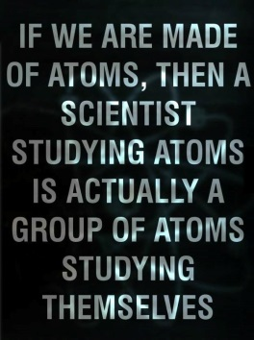
- “The grand underlying principles have been firmly established.”
Albert A. Michelson 1894

- “In science there is only physics; all the rest is stamp collecting.”
Lord Rutherford.

- “There is nothing new to be discovered in physics now. All that remains is more and more precise measurement.”
Lord Kelvin at the British Association of Science in the year 1900.

- Protons give atoms their identity, electrons give them their personality. What does this phrase mean?

Student notes

The plum pudding model of the atom

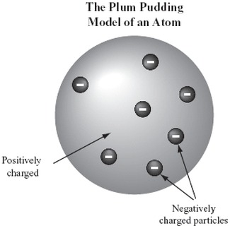
In the early 1900’s the most popular model of the atom was the ‘plum pudding’ model; this assumed the atom is composed of negative charges (electrons) embedded in a positively charged sphere like negatively-charged "plums" embedded in a positively-charged "pudding".

Rutherford’s (or Geiger-Marsden’s) gold foil experiment

By 1909 it was known that alpha-particles can get deflected when they cross a film of gold foil. This was quite unexpected because the speed and size of the alpha particles relative to the target suggested that they should go straight through. New Zealand physicist Ernest Rutherford decided to investigate this further and asked his colleague Hans Geiger and one of their students (Ernest Marsden) to do this.

The alpha particles could be detected by small flashes of light that they produced on a fluorescent screen (see diagram).

What Rutherford discovered was mind-blowing:
- Most alpha particles were undeflected and passed straight through the gold foil (as expected).
- Some were deflected through small angles (as expected – but they didn’t know why).
- A very small number were turned back through angles greater than 90⁰!

There was simply no way to explain the fact that some alpha particles were bouncing backwards using the standard ‘plum pudding’ interpretation.
It took Rutherford quite some time to make sense of it but eventually he realised that the only explanation must be the following:The atom is mostly empty space, but there is a solid very small centre, which has a positive charge.The electrons orbits a this center (now known as the nucleus).
He described his astonishment at the results in very graphic terms: “It was quite the most incredible event that ever happened to me in my life. It was as incredible as if you fired a 15-inch shell at a piece of tissue paper and it came pack and hit you!”

2020 Question 11 [Higher level]
Describe the Geiger‐Marsden experiment that used thin sheets of gold. Include their setup, observations and conclusions.
Marking scheme:
- Setup and observations:
- Zinc sulphide or fluorescent screen, alpha source, gold foil, vacuum
- Flashes on screen / scintillations
- Most alphas straight through / deviated slightly
A few alphas reflected Conclusion: Atom mostly empty space with small/dense positive core


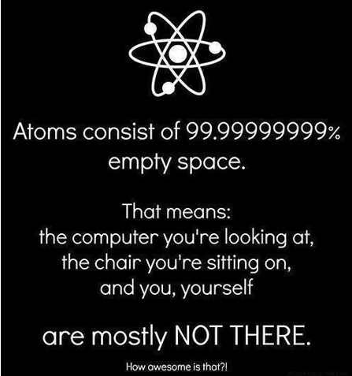

Why is glass transparent?
When you think about it, the real question should be: “given that the atom is almost completely empty space, why isn’t everything transparent?”
What determines whether or not light can travel unimpeded through an atom?
Answer: Electrons, or more specifically, the arrangement of electrons in the medium.

Metals and most solids are not transparent because they consist of ‘a sea of free electrons’ which, because they're free, have lots of different energy levels and so can absorb lots of different frequencies of incident light. Glass is the opposite, a solid where the electrons are arranged in just a small variety or ways. This means that there are a limited number of energy levels that the electrons can have and a limited number of frequencies that they can absorb. The energy levels that are available are relatively large and there isn’t enough energy in photons of visible light to bump electrons up to these levels so this light simply doesn’t get absorbed so travels straight through, whereas photons of ultraviolet light do have enough energy to bump electrons up to these higher levels so they get absorbed by the glass. So glass is transparent to visible light but not to ultra violet light.

Neutron stars
Neutron stars get my nomination for one of the wonders of the universe (one of the other contenders is mans’ blissful ignorance of the fact that we are on the path to our very own extinction).

They seem to be composed almost entirely of neutrons so they don’t contain vast amounts of empty space (at the atomic level) and as a result they are incredibly dense.
How dense?
Well I’m very glad you asked . . .

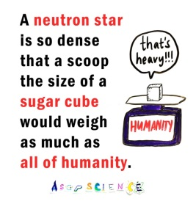
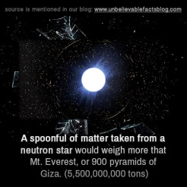


Dame Jocelyn Bell Burnell – one of my all-time heroes

Atomic numbers, mass numbers and isotopes

The atomic number (Z) of an atom tells us the number of protons present in the atom.

The mass number (A) of an atom tells us the number of protons plus neutrons present in the atom.

Number of neutrons in an atomic nucleus = mass number – atomic number.

Isotopes are atoms which have the same atomic number but different mass numbers.
For example carbon-12 has 6 protons and 6 neutrons, while carbon-14 has 6 protons and 8 neutrons.
Therefore carbon-12 and carbon-14 are isotopes.
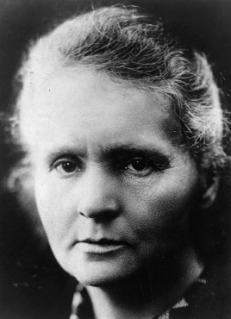

2021 Question 12 [Ordinary Level]
Marie Curie has an element named after her, curium, Cm. One isotope of curium is ${Cm}_{96}^{247}$
How many neutrons are in this isotope?

Solution
Number of neutrons = mass number – atomic number = 247 – 96 = 51 neutrons

Using the Forumlae & Tables book

The layout of the booklet is incredibly poor so you should practice using it as much as possible to become familiar with the location of all relevant information.

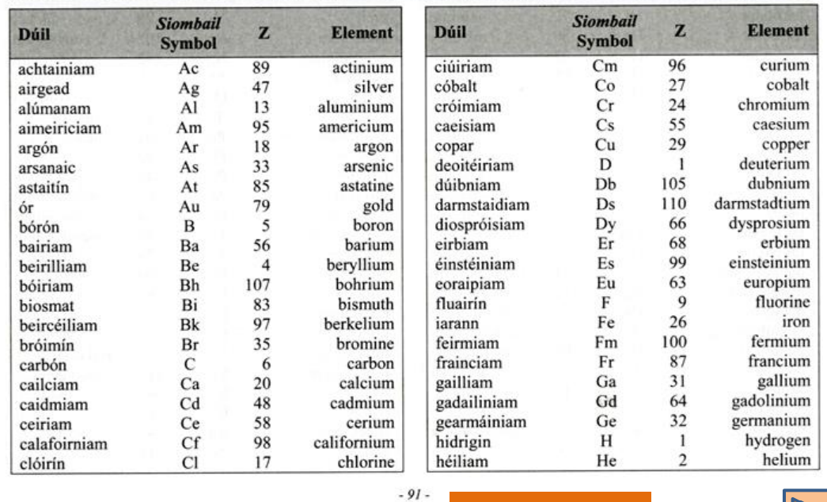
Elements, sorted by symbol pages 91 - 93

Scientists discover new element

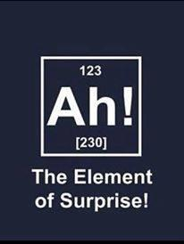

Atomic numbers and mass numbers – pages 79 & 82

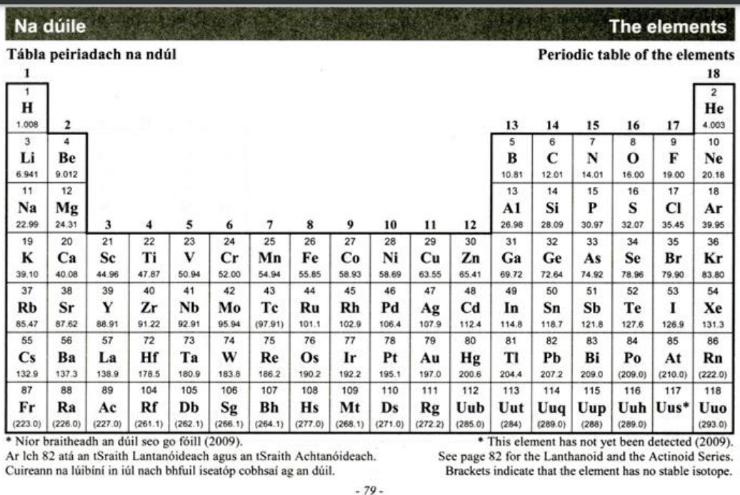

Don’t forget about page 82!
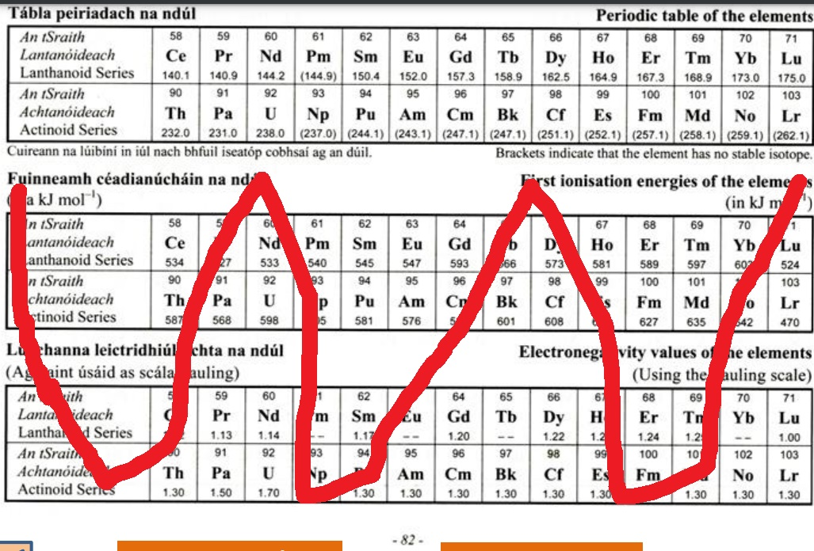

2: Radioactivity

Radioactivity is the disintegration of unstable nuclei with the emission of one or more types of radiation.
You must specify nuclei, not atoms.

However, stable (and therefore non-radioactive) atoms can be made radioactive by bombarding them with neutrons.
These atoms are known as artificial radioactive isotopes or radioisotopes and are used in industry for the following:

Medical imaging / Medical therapy / Food irradiation / Radiocarbon dating / Agriculture / Smoke detectors

Why is radioactivity dangerous?
Because it can cause ionisation. We first encountered this concept when we studied the electromagnetic spectrum and noted that ultra-violet radiation, X-rays and gamma rays can all cause ionisation and are therefore potentially carcinogenic. Did I mention that suntanned skin is damaged skin?

Ionisation occurs when an atom loses or gains an electron.
An ion is a charged atom.

Alpha, beta and gamma radiation
The three different types of radiation emitted during radioactive decay are called alpha, beta and gamma radiation.

Alpha radiation (α)

Alpha decay occurs when an unstable nucleus spits out an alpha particle and in doing so changes to another element.

An alpha particle is identical to a helium nucleus (2 protons and 2 neutrons).
As a result the mass number of the parent atom decreases by four and its atomic number decreases by two.
Charge = +2

Since the alpha particles have a relatively large charge they cause a lot of ionisation as they pass through a material. Consequently they lose their energy quickly and their penetrating ability is poor.

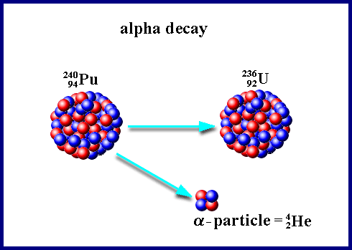
The image on the right represents the radioactive decay of ${}_{94}^{240}{Pu}$ into ${}_{92}^{236}U$ plus alpha particle.
$${}_{94}^{240}{Pu} →{}_{2}^{4}{He+ {}_{92}^{236}U}$$

[2016 Higher level]
A polonium–212 nucleus decays spontaneously with the emission of an alpha-particle.
What daughter nucleus is produced during this alpha-decay?

Solution
Use the periodic table of elements to find the atomic number of polonium. It’s 84.
So this is the situation: on the left hand side you have the original atom (in this case polonium). On the right hand side you have the ‘daughter products’ consisting of the alpha particle and one other atom. Our job is to identify this new atom:
$${}_{84}^{212}{Po} →{}_{2}^{4}{He+ {}_{?}^{?}X}$$
Now the total number on top must be the same on both sides (still the same number of protons and neutrons before and after). In this case we have 212 on the left hand side so the total on the right hand side must add up to 212.
The same applies for the bottom, therefore the bottom number is 82. So we have the following:
$${}_{84}^{212}{Po} →{}_{2}^{4}{He+ {}_{82}^{208}X}$$

Now go to page 79 so see that element 82 has got the symbol Pb and then go to page 92 to identify the element as lead so now we can finally write out our equation in full:

$${}_{84}^{212}{Po} →{}_{2}^{4}{He+ {}_{82}^{208}{Pb}}$$
Problems involving alpha decay

2020 Question 12 (d) [Ordinary Level]  The nuclear equation below shows the alpha decay of an isotope of radon.  $${Rn}_{86}^{220}→X_{A}^{Z}+ α_{2}^{4}$$  - Calculate the atomic number, A, of the unknown element X.  - Calculate the mass number, Z.  - Name element X. | The total on the top of the right hand side must add up to 220, so A = 220 – 4 = 216  A = 216  The total on the bottom of the right hand side must add up to 86, so Z = 86 – 2 = 84  Z = 84  Now go to page 79 so see that element 84 has got the symbol Po and then if you need to you go to page 92 to identify the element as polonium.
2022 Question 14 (d) [Ordinary Level]  - Radium ${(Ra}_{88}^{226})$ is an alpha emitter.  How many neutrons are there in an atom of ${(Ra}_{88}^{226})$?  - What is the daughter nucleus when an atom of ${(Ra}_{88}^{226})$ emits two alpha particles? | Mass number or radium = 226  Atomic number of radium = 88  Number of neutrons = 226 – 88 = 138  When ${Rn}_{86}^{222}$ loses two alpha particles its mass number drops by 4 and its atomic number drops by 8.  86-8=78
2019 Question 5 [Higher level]  Polonium–218 is produced as the daughter nucleus in the alpha‐decay of radon–222.  Write a nuclear equation for this reaction. | $${Rn}_{86}^{222}→{Po}_{84}^{218}+ {He}_{2}^{4}$$

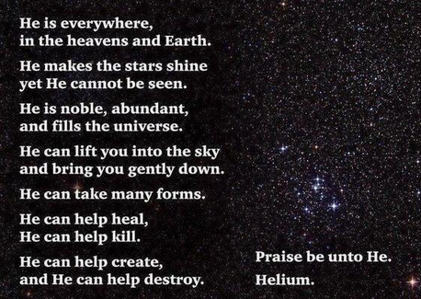

Beta radiation (β)

In this case a neutron decays into an electron and a proton (and a neutrino!!)

$${}_{0}^{1}n→{}_{-1}^{0}e+{}_{1}^{1}p$$

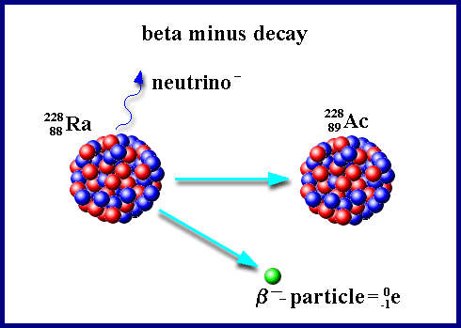
A beta particle is therefore identical to a fast moving electron.
You must include the term ‘fast moving’.

They are less ionising and therefore more penetrative than alpha particles. Charge = -1

[2005 Higher level]
Cobalt−60 is a radioactive isotope and emits beta particles.
Write an equation to represent the decay of cobalt−60.

Solution
Use the periodic table of elements to find the atomic number of cobalt. It turns out to be 27. So this is the situation: on the left hand side you have the original atom (in this case cobalt). On the right hand side you have the ‘daughter products’ consisting of the beta particle and one other atom. Our job is to identify this new atom.
$${}_{27}^{60}{Co}→{}_{-1}^{0}e+{}_{?}^{?}X$$

Now the total number on top must be the same on both sides. In this case we have 60 on the left-hand side so the total on the right hand side must add up to 60.
The same applies for the bottom. So we have the following:
$${}_{27}^{60}{Co}→{}_{-1}^{0}e+{}_{28}^{60}X$$

Once you realise that the atomic number of the daughter product is 28 you then go to the periodic table of elements to identify this atom – it this case the element ‘Nickel’ has an atomic number of 28 so now we can finally write out our equation in full:
$${}_{27}^{60}{Co}→{}_{-1}^{0}e+{}_{28}^{60}{Ni}$$
Problems involving beta decay

2003 Question 11 [Higher Level]  ¹⁴C decays to ¹⁴N.  Write an equation to represent this nuclear reaction. | $${}_{6}^{14}C→{}_{-1}^{0}e+{}_{7}^{14}N$$
2007 Question 12 (d) [Higher Level]  Carbon-14 decays by beta emission.  Write a nuclear equation to represent the decay of carbon-14. | $${}_{6}^{14}C→{}_{-1}^{0}e+{}_{7}^{14}N$$
2005 Question 8 [Higher Level]  Cobalt−60 is a radioactive isotope and emits beta particles.  Write an equation to represent the decay of cobalt−60. | $${}_{27}^{60}{Co}→{}_{-1}^{0}e+{}_{28}^{60}{Ni}$$
2017 Question 12 (b) [Higher Level]  Potassium–40 is a beta-emitter.  Write the nuclear equation for this decay. | $${}_{19}^{40}K→{}_{-1}^{0}e+{}_{20}^{40}{Ca}$$
2013 Question 9 [Higher Level]  Iodine–131 decays with the emission of a beta-particles.  Write an equation for the beta-decay of iodine–131. | $${}_{53}^{131}I→{}_{-1}^{0}e+{}_{54}^{131}{Xe}$$
2016 Question 9 [Higher Level]  Radium–225 is a radioactive isotope that decays into an isotope of actinium.  Write a nuclear equation for the decay of radium–225 | $${}_{88}^{225}{Ra→}{}_{89}^{225 }{Ac+ {}_{-1}^{0}e}$$
2022 Question 10 [Higher level]  A nucleus of plutonium–239 can absorb two neutrons to produce plutonium–241.  - Write a nuclear equation for the conversion of plutonium–239 into plutonium–241.  - This isotope of plutonium then undergoes beta decay to produce americium–241.  Write a nuclear equation for the conversion of plutonium–241 into americium–241. | - ${}_{94}^{239}{Pu+2{}_{0}^{1}n→{}_{94}^{241}{Pu}}$  - ${}_{94}^{241}{Pu→}{}_{95}^{241}{Am}+{}_{-1}^{0}e$

Decay chain question involving alpha plus beta
2020 Question 8 [Higher level]
In the uranium decay series, U–238 decays to Pb-206 in a series of alpha and beta decays.
The first decay in this series is an alpha decay and the final decay is a beta decay.
- Write a nuclear equation for the first decay in this series.
- Write a nuclear equation for the final decay in this series.
- Calculate the total number of alpha particles and the total number of beta particles emitted in the series

- Write a nuclear equation for the first decay in this series.
We know that U-238 must be on the left hand side and there has to be an alpha particle on the right hand side so then we just need to work out the atomic number and mass number of the element on the right hand side:
$${}_{92}^{238}U →{}_{2}^{4}{He+ {}_{90}^{234}{Th}}$$

- Write a nuclear equation for the final decay in this series.
We know that Pb-206 plus a beta particle must be on the right hand side so then we just need to work out the left hand side:
$${}_{81}^{206}{Tl} →{}_{-1}^{0}{e+ {}_{82}^{206}{Pb}}$$

- Calculate the total number of alpha particles and the total number of beta particles emitted in the series
The series starts with uranium (U) and finishes with lead (Pb).
$${}_{92}^{238}U →{}_{82}^{206}{Pb}$$

We start off by sorting out the top.
Adding the correct number of alpha particles $({}_{2}^{4}{He}$) on the right-hand side will do this for us:
238 = X + 206 X = 32, so this tells us that we need 8 alpha particles .

$${}_{92}^{238}{U=8(}{}_{2}^{4}{He)}+{}_{82}^{206}{Pb}$$
Now we sort out the bottom.
The bottom of the left-hand side is 92 while the bottom of the right hand side is 98 (made up of 82 from Pb plus 16 from 8 alpha particles). Adding 6 beta particles $({}_{-1}^{0}{e)}$ will sort this out (and won’t mess up our top number, which is why we do this part last).

$${}_{92}^{238}{U=8(}{}_{2}^{4}{He)}+6({}_{-1}^{0}{e)}+{}_{82}^{206}{Pb}$$
Answer: 8 alpha and 6 beta

Gamma radiation (γ)

Gamma radiation is radiation of very short wavelength (and therefore high frequency and therefore high energy (from E =hf)).
It is uncharged and so its ionising ability is relativity poor but it is highly penetrating.

There is no change in atomic number or mass number, so there is no equation as such.
Gamma radiation usually only accompanies alpha and beta decay.

Detecting radiation: The Geiger-Muller tube

Principle: A charged particle passing through a gas leaves in its wake a trail of electron-ion pairs, like a bull in a china shop. The electrons then accelerate up to the anode where they get detected as an electronic pulse.

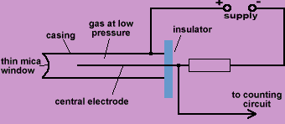
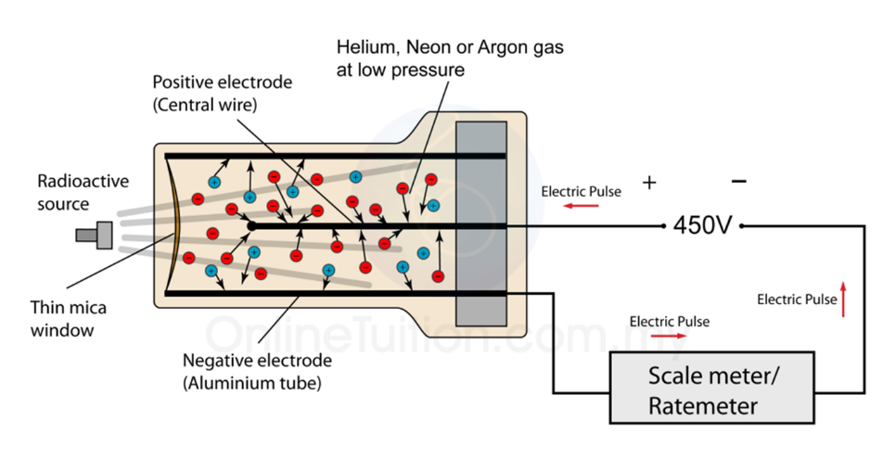
- Radiation (which could be alpha, beta or gamma) enters through the thin window on the left.
- It causes ionisation of some of the rare-earth gas molecules inside (these gases have low ionisation energies).
- The negative ions (electrons) accelerate towards the anode (central wire), colliding off (and ionising) other gas molecules along the way, giving rise to an avalanche effect.
- Positive ions accelerate towards the cathode (negative electrodes on the outside) with the same end result.
- These ions all reach the anode more or less together and are detected as a pulse.
- The G-M tube may in turn be connected to a counter or loudspeaker or (in our case) both.

Exam tip: Your answer must make reference to: anode & cathode, ionisation, low pressure gas and the avalanche effect

Using a G-M tube to investigate the range of alpha, beta and gamma radiation in air

- Place the alpha source in front of the detector.
- Find the average count rate per second due to background radiation.
- Move the detector away from the source in small steps and calculate the average count rate at each step.
- Continue until count rate equals background count rate.
- Repeat for beta and gamma sources.

Result
The gamma radiation will be detected at the greatest distance (from source to detector), and alpha radiation the least.

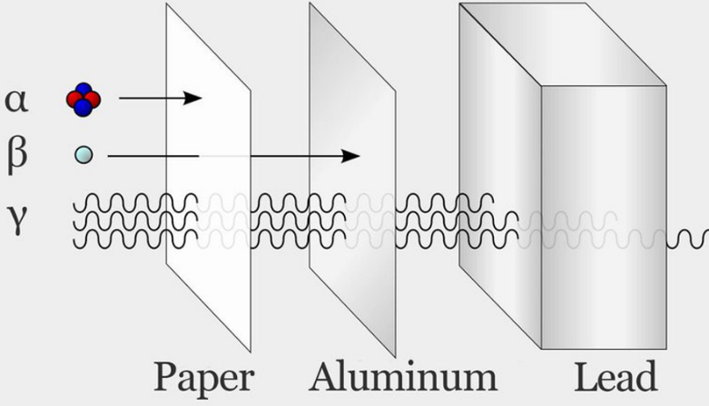
Note
We could also have tested the penetrative ability of the different sources in a similar fashion, by placing different materials between source and detector.
We would find that a few sheets of paper would stop alpha, aluminium would be required to stop beta radiation while lead is necessary to stop gamma radiation.

And finally, if we were presented with three different sources, one of which was alpha-emitting, one was beta-emitting and one was gamma-emitting then we could use the same approach to identify which was which.
By the way, can you spot why this is a terrible diagram to illustrate this (even if it does get the message across)?

They should all be of equal thickness for it to be a fair test. I imagine if you use a lump of aluminium that’s as thick as the lead it would stop everything also.
There’s also the issue that the alpha and beta are represented as particles while the gamma is represented as a wave. Technically we can prove that all three types are both particles and waves, but that’s for another day.

Do you use a geothermal heat pump as part of your home heating system? If so then you are using nuclear energy. The earth increases in temperature the deeper you go. The heat comes from the decay of naturally occurring radioactive elements in the Earth's interior similar to those mentioned in these pages.
Not a lot of people know that.

Can you identify the three sources X, Y and Z from the information in this diagram?



https://xkcd.com/2607/

α,β,γ behaviour in presence of electromagnetic field:

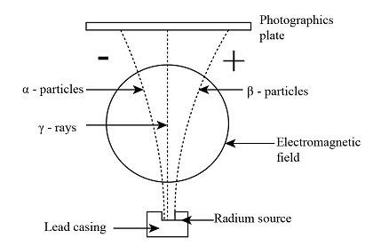

Relationship between Activity (A) and number of radioactive nuclei (N)

The more radioactive atoms that are present, the greater will be the activity (the number of disintegrations or decays per second).
This is summed up by the law of radioactive decay:
The law of radioactive decay states that the activity is proportional to the number of nuclei present.

The symbol for activity is A and the unit of activity is the becquerel (Bq).
Note that this is just a single number.
One becquerel (Bq) corresponds to one disintegration per second.

Mathematically: Activity ∝ N
A = λ N
$\frac{dN}{dt}$ = λN
⇒ or as it appears in the Formulae & Tables book:

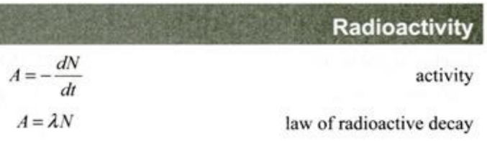
Where N = number of radioactive nuclei present and λ is called the decay constant.
The unit of decay constant is s⁻¹.



Half-life ($T_{1/2}$)
In one of the stranger ideas you will ever encounter in your life, it turns out that there is no way to predict
when an individual radioactive atom will undergo decay. However if we have a large enough number of atoms we can work out how long it takes half of them to decay, and that length of time remains constant until we only have a small number of atoms left, in which case we can no longer apply laws of probability.
As we have already seen, radioactivity is a random process; it is impossible to predict exactly when a particular radioactive atom will decay.
The half-life of an element is the time taken for half the radioactive nuclei in the sample to decay.
(Make sure that you specify the word ‘nuclei’ and not ‘atoms’.)


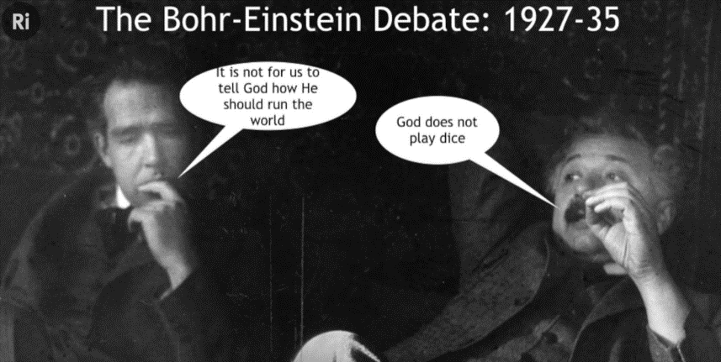
Or, because the activity is proportional to the number of radioactive atoms present, we can also say that the half-life of an element is the time taken for the activity (of that sample) to be halved.
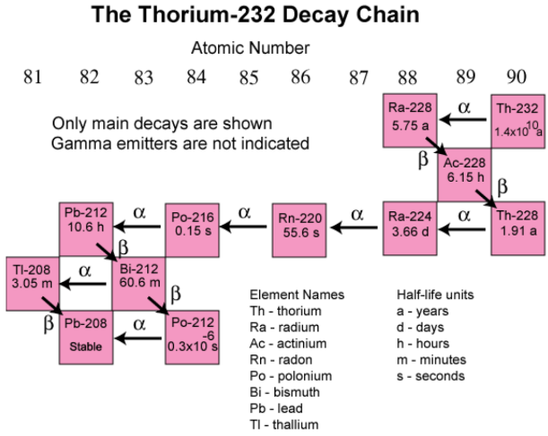

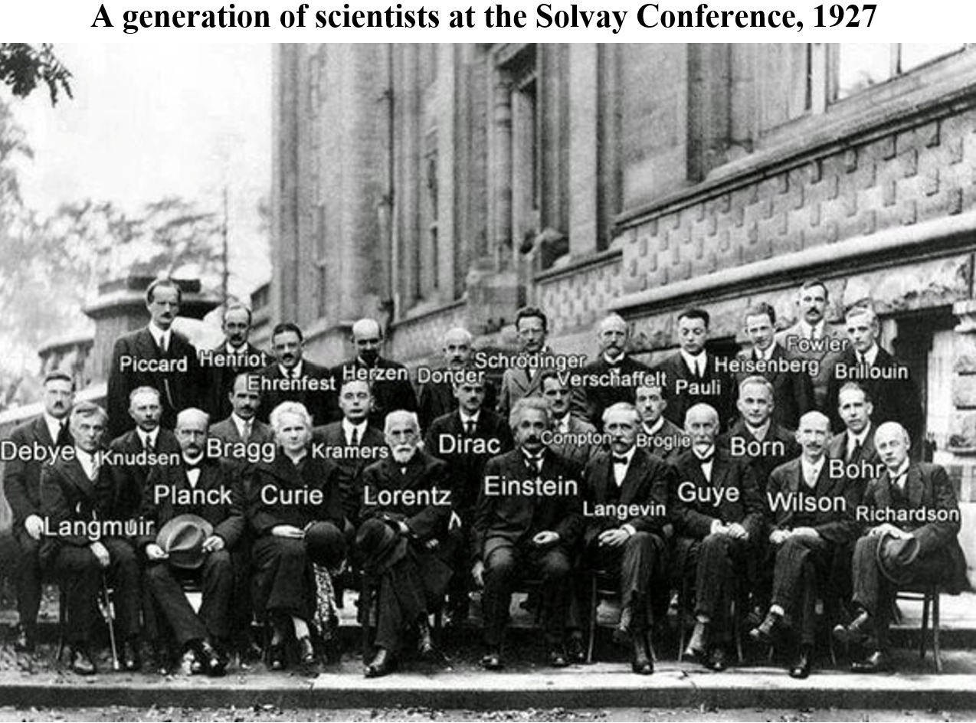

The Solvay conferences were a series of famous conferences sponsored by the Belgian industrialist Ernest Solvay. He wanted the brightest minds of the day to come together to try and make sense of recent developments in the world of physics. The first one was held in 1911 and the photo above is of the attendees at the 1927 conference. Watch the video clip below for a spine-tingling view of the giants of the time. You couldn’t make this up. https://www.youtube.com/watch?v=jOFiETncmZM

Half-life exam questions

2007 Question 5 [Ordinary level]  The half life of a radioactive element is 3 days.  What fraction of a sample of the radioactive element will remain after 9 days? | After 3 days (one half-life) ½ would remain  after 6 days (two half –lives) ¼ would remain  after 9 days (three half-lives) ⅛ would remain.
Note that we could also use the fact that after n half-lives the fraction undecayed = $\frac{1}{2^{n}}$

2014 Question 10 [Ordinary Level]  Iodine–131 is a product of nuclear fission.  The half-life of iodine–131 is 8 days.  What fraction of iodine–131 remains after 24 days? | The half-life is 8 days, so  after l half-life (8 days) ½ would remain,  after 2 half-lives (16 days) ¼ would remain,  after 3 half-lives (24 days) ⅛ would remain
2005 Question 12 (d) [Ordinary Level]  Na−25 is a radioactive isotope of sodium. It has a half life of 1 minute.  What fraction of a sample of Na−25 remains after 3 minutes? | The half-life is 1 minute, so  after l half-life 1 minute) ½ would remain,  after 2 half-lives (2 minutes) ¼ would remain,  after 3 half-lives (3 minutes) ⅛ would remain  After 3 minutes 7/8^{ths} has decayed and ⅛ remains.
2012 Question 5 [Higher level]  It takes 30 minutes for a 100 g sample of a radioactive isotope to decay to 12.5 g.  What is the half-life of the radioisotope? | It takes one half-life to go from 100 g to 50 g,  another half-life to go from 50 g to 25 g  and another half-life to go from 25 g to 12.5 g.  So 30 mins corresponds to 3 half-lives.  Therefore one half-life = 10 mins = 600 seconds
2004 Question 5 [Higher level]  The activity of a radioactive isotope decays to 1/16th of its original value after 36 years.  What is the half-life of the isotope? | 1 → ½ → ¼ → ⅛ → 1/16  It takes 4 half-lives to get from the original amount to 1/16th of the original.  4 half-lives took 36 years, so one half-life must be 9 years.  Answer: 9 years
2013 Question 9 [Higher Level]  Iodine–131 has a half-life of 8 days.  Estimate the fraction of the iodine–131 that remained after 40 days. | 1 → ½ → ¼ → ⅛ → 1/16→ 1/32  40 days corresponds to 5 half-lives  After 5 only 1/32 will remain
2020 Question 8 [Higher level]  The half‐life of U–238 is 4.5 × 10⁹ years.  How long will it take for the number of U-238 nuclei in a sample to decrease by a factor of 8? | ½ × ½ × ½ = 3 half lives  3 × (4.5 × 10⁹) = 1.35 × 10¹⁰ years
2015 Question 12 (d) [Higher Level]  Radon–210 decays by alpha-emission with a half-life of 144 minutes.  A sample of the gas contains 4.5 × 10¹⁵ atoms of this isotope.  How many radon–210 atoms will remain after one day? | The sample of the gas contains 4.5 × 10¹⁵ atoms and this number halves after each half life.  The number of minutes in a day = 24 × 60 = 1440 minutes  The half-life of radon-210 is 144 mins, so there are 10 half-lives in one day.  (4.5 × 10¹⁵) × ½ × ½ × ½ × ½ × ½ × ½ × ½ × ½ × ½ × ½ = 4.4 ×10¹² atoms

2007 Question 12 (d) [Higher Level]  An ancient wooden cup from an archaeological site has an activity of 2.1 Bq.  The corresponding activity for newly cut wood is 8.4 Bq.  If the half-life of carbon-14 is 5730 years, estimate the age of the cup. | It takes one half-life for the activity to decrease from 8.4 Bq to 4.2 Bq.  It takes another half-life for the activity to decrease from 4.2 Bq to 2.1 Bq.  It therefore requires two half-lives to go from 8.4 Bq to 2.1 Bq  Each half-life is 5730 years. Therefore the total time that has passed is 11,460 years.  The cup is 11,460 years old.
2022 Question 11 [Higher level]  The ratio of C–14 to C–12 in a sample from an archaeological artefact is found to be one quarter the ratio found in a living tree. Is the artefact from the Bronze Age (the Bronze Age began about 5000 years ago). Justify your answer.  half-life of carbon–14 = 5730 years | No.  The time taken for the ratio to drop to one quarter corresponds to two half-lives or 11,430 years so it is much older than the Bronze Age.



I once saw a book called, “How to solve 50% of your problems”.
So I bought two books.
Problem solved.

Relationship between half-life (T_{½}) and the decay constant (λ)
$$T_{1/2}=\frac{ln 2}{λ}$$

2009 Question 12 (d) [Higher Level]  Americium-241 has a decay constant of  5.1 × 10^{–11} s^{–1}.  Calculate its half-life in years. | T_{½} = $\frac{\ln{2}}{λ}$ $T_{1/2}= \frac{\ln{2 }}{ 5.1 × {10}^{-11}}$  = 1.36 × 10¹⁰ seconds  To convert from seconds to years we need to divide by the number of seconds in a year: (365×24×60×60)  Answer: 430.6 years
2013 Question 9 [Higher Level]  Caesium–137 has a half-life of 30 years .  Calculate the decay constant of caesium–137.  Note that half-life must be in seconds | $T_{\frac{1}{2}}= \frac{\ln{2}}{λ}$ $λ= \frac{\ln{2}}{T_{\frac{1}{2}}}$  $T_{1/2}$ = (30)(365)(24)(60)(60) = 9.46 × 10⁸ secs  $λ= \frac{\ln{2}}{T_{\frac{1}{2}}}$ $λ= \frac{\ln{2}}{9.46×{10}^{8}}$ = =$7.32 × {10}^{-10} s^{-1}$
2005 Question 8 [Higher Level]  Cobalt−60 is a radioactive isotope with a half-life of 5.26 years.  Calculate the decay constant of cobalt−60. | $T_{1/2}=\frac{ln2}{λ}$ $λ=\frac{\ln{2}}{T_{1/2}}$  $T_{\frac{1}{2}}=$5.26 years = 1.66 × 10⁸ seconds  $λ=\frac{0.693}{1.66 ×{ 10}^{8}}$ λ = 4.18 × 10⁻⁹ s⁻¹
2022 Question 10 [Higher level]  Americium–241 has a half-life of 432 years.  Calculate the decay constant for americium–241. | $T_{\frac{1}{2}}=\frac{ln2}{λ}$ $λ=\frac{\ln{2}}{\left(432\right)\left(365\right)\left(24\right)\left(60\right)\left(60\right)}$  λ = 5.09 × 10^{–11} s^{–1}

Maths questions involving activity and half-life

Maths questions on this topic are a little like comprehension questions; you need to read the question a couple of times and then underline each relevant point of information.

Remember there are only two formulae:

A = λ N | and | $$T_{1/2}=\frac{ln 2}{λ}$$

The activity can be referred to in a number of various ways:
- the number of disintegrations per second
- the decay rate / the rate of decay
- the number of particles emitted per second
- the number of particles undergoing decay per second

2019 HL Question 5 [Higher Level]  Polonium–218 has a half‐life of 3 minutes.  Calculate the activity of a sample of polonium–218 that contains 75000 nuclei. | The symbol for the number of nuclei is N and the formula that relates N to the activity A is A = λ N  So first we need to find λ - the decay constant  $λ=\frac{ln2}{T_{1/2}}$ =$\frac{ln2}{\left(3\right)(60)}$ = 0.00385 s⁻¹  A = $λN$ = (0.00385)(75000) = 289 Bq
2017 Question 12 (b) [Higher Level]  Potassium–40 has a half-life of 1.25 × 10⁹ years.  The activity of a human body due to potassium–40 is 5400 Bq.  Calculate the number of potassium–40 nuclei in this person. | $T_{1/2}=\frac{0.693}{λ}$ $λ=\frac{0.693}{T_{1/2}}$  Potassium–40 has a half-life of 1.25 × 10⁹ years (which needs to be converted to seconds).  $λ=\frac{0.693}{(1.25 × {10}^{9})(365)(24)(60)(60)}$  A = λ N $N= \frac{A}{λ}$ $= \frac{5400}{λ}$ = 2.07 × 10²⁰ nuclei
2020 Question 8 [Higher level]  A sample of U-238 contains 3.2 × 10¹⁰ nuclei.  The half‐life of U–238 is 4.5 × 10⁹ years.  Calculate its activity. | $T_{\frac{1}{2}}=\frac{ln2}{λ}$ $λ=\frac{ln2}{T_{\frac{1}{2}}}$  $$λ=\frac{ln2}{(4.5×{10}^{9})(60)(60)(24)(365)}$$  $A= λN$ $=\left[\frac{ln2}{\left(4.5×{10}^{9}\right)\left(60\right)\left(60\right)\left(24\right)\left(365\right)}\right][3.2×{10}^{10}]$  A = 1.56 × 10⁻⁷ Bq
2005 Question 8 [Higher Level]  Cobalt−60 is a radioactive isotope with a half-life of 5.26 years.  - Calculate the decay constant of cobalt−60.  - Calculate the rate of decay of a sample of cobalt−60 when it has 2.5 × 10²¹ atoms. | $T_{\frac{1}{2}}=\frac{ln2}{λ}$ $λ=\frac{ln2}{T_{\frac{1}{2}}}$  $λ=\frac{0.693}{1.66 ×{ 10}^{8}}$ = 4.18 × 10⁻⁹ s⁻¹  A = λN = (4.18 × 10⁻⁹)( 2.5 × 10²¹)  = 1.04 × 10¹³ Bq
2016 Question 9 [Higher Level]  Radium–225 has a half-life of 14.9 days.  Calculate the number of radium–225 nuclei in a sample that has an activity of 5600 Bq. | $T_{\frac{1}{2}}$ = $\frac{\ln{2}}{λ}$ λ = $\frac{ln 2}{T_{1/2}}$ = $\frac{0.693}{14.9×25×60×60}$  λ = 5.38 × 10^{–7} s^{–1}  A = λN N =$\frac{A}{λ}$ = $\frac{5600}{5.38 × {10}^{–7}}$  N = 1.04 × 10¹⁰ nuclei
2011 Question 12 (d) [Higher Level]  Calculate the number of atoms present in a sample of Sr-90 when its activity is 4250 Bq.  The half-life of Sr-90 is 28.78 years. | $T_{1/2}$= (28)(365)(24)(60)(60) = 907606080 seconds  T_{½} = $\frac{\ln{2}}{l}$ = $\frac{\ln{0.693 }}{l}$ λ = $\frac{0.693}{T_{1/2 }}$  λ = $\frac{0.693}{907606080}$ = 7.637 × 10⁻¹⁰ s⁻¹  A = λN 4250 = (7.637 × 10⁻¹⁰)(N)  N = 5.565 × 10¹² atoms
2013 Question 9 [Higher Level]  Caesium–137 has a half-life of 30 years .  The activity of a sample was measured at 5000 Bq.  - Calculate the decay constant of caesium–137.  - Hence calculate the number of caesium–137 atoms present in the sample. | $T_{\frac{1}{2}}= \frac{\ln{2}}{λ}$ $λ= \frac{\ln{2}}{T_{\frac{1}{2}}}$  $T_{1/2}$ = (30)(365)(24)(60)(60) = 9.46 × 10⁸ seconds  $λ= \frac{\ln{2}}{T_{\frac{1}{2}}}$ $λ= \frac{\ln{2}}{9.46×{10}^{8}}$ $= 7.32 × {10}^{-10} s^{-1}$  A = λN  $N= \frac{A}{ λ}$ = $\frac{5000}{7.32 × {10}^{-10}}$ N = 6.83 × 10¹² atoms
2011 Question 12 (d) [Higher Level]  Calculate the number of atoms present in a sample of Sr-90 when its activity is 4250 Bq.  The half-life of Sr-90 is 28.78 years. | $T_{1/2}$= (28)(365)(24)(60)(60) = 907606080 seconds  T_{½} = $\frac{\ln{2}}{l}$ = $\frac{\ln{0.693 }}{l}$ λ = $\frac{0.693}{T_{1/2 }}$ λ = $\frac{0.693}{907606080}$ λ = 7.637 × 10⁻¹⁰ s⁻¹  Activity = λN 4250 = (7.637 × 10⁻¹⁰)(N)  N = 5.565 × 10¹² atoms
2016 Question 9 [Higher Level]  Radium–225 has a half-life of 14.9 days.  Calculate the number of radium–225 nuclei in a sample that has an activity of 5600 Bq. | T_{1/2} = $\frac{\ln{2}}{λ}$ λ = $\frac{ln 2}{T_{1/2}}$ = $\frac{0.693}{14.9×25×60×60}$ = 5.38 × 10^{–7} s^{–1}  Activity = λN N = $\frac{A}{λ}$ = $\frac{5600}{5.38 × {10}^{–7}}$ = 1.04 × 10¹⁰ nuclei

2022 Question 10 [Higher level]  Americium–241 has a half-life of 432 years.  241 g of americium–241 contains 6.0 × 10²³ nuclei.  A typical smoke detector contains 0.29 μg of americium–241.  - Calculate the decay constant for americium–241.  - Calculate the activity of the americium in the smoke detector. | $T_{\frac{1}{2}}=\frac{ln2}{λ}$ $λ=\frac{\ln{2}}{\left(432\right)\left(365\right)\left(24\right)\left(60\right)\left(60\right)}$ = 5.09 × 10^{–11} s^{–1}  A = λN  Next we need to calculate N - the number of nuclei  241 g contains 6.0 × 10²³ nuclei so 1g contains $\frac{{6×20}^{23}}{241}$.  0.29 μg = $(\frac{{6×20}^{23}}{241})({0.29×10}^{-6})$ = 7.22 × 10¹⁴ nuclei  A = λN (5.09 × 10⁻¹¹) × (7.22 × 10¹⁴) = 3.67 × 10⁴ Bq

Decay curves
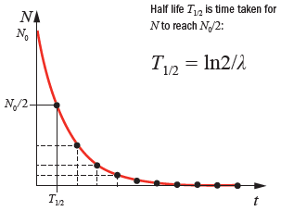
A graph of number of radioactive nuclei against time is called a ‘decay curve’. Each radioactive element has its own unique decay curve.
Using a decay curve to establish the half-life of a radioactive element

- Pick any number ’N’ and note the corresponding time using the graph. Call this t₁.

- Now go to $\frac{N}{2}$ and note the corresponding time for that number. Call this t₂.

- Half-life corresponds to the time to go from N to $\frac{N}{2}$.
$T_{\frac{1}{2}}$ = t₂ – t₁.

An easier alternative is to simply start at time t = 0 and note the value for N at that stage (N₀).
The half-life is then simply the value of t corresponding to $\frac{N_{0}}{2}$. Can you see why?

Remember from the law of radioactive decay that the activity A is proportional to N, so we if plot a graph of A against time rather than N against time we would get a similar decay curve.
See exam question below.

2018 Question 12 (b) [Higher Level]
The radioactivity of an isotope of radon was measured each day for a week and the following data were recorded.
Time (days) | 0 | 1 | 2 | 3 | 4 | 5 | 6 | 7
Activity (MBq) | 600 | 490 | 400 | 330 | 270 | 220 | 180 | 150

- On graph paper, draw a decay curve (a graph of activity against time).
- Use the decay curve to determine the half‐life of the isotope.
- Calculate the number of nuclei in the sample at the beginning of the investigation.

Ionization and radioactivity

To demonstrate the ionizing effect of radioactivity

Procedure: Bring a radioactive source close to the cap of a charged gold leaf electroscope
(assume positively charged).
Observation: Leaves collapse
Conclusion: The radioactive source ionised the air. The newly-formed negative ions then accelerate towards the gold leaf electroscope and neutralise it causing the legs to collapse.
The same thing would happen if the gold leaf electroscope was negatively-charged initially.

Factors which determine the effect of ionising radiation on humans
- The type of radiation (whether it’s alpha, beta or gamma)
- The activity of the source (in Bq)
- The time of exposure
- The type of tissue irradiated.

Precautions when dealing with ionising radiation
- Make sure sources are properly shielded.
- Keep sources as distant as possible from human contact, eg use a pair of tongs (and not, as one official safety brochure advised, a pair of thongs).
- Use protective clothing.

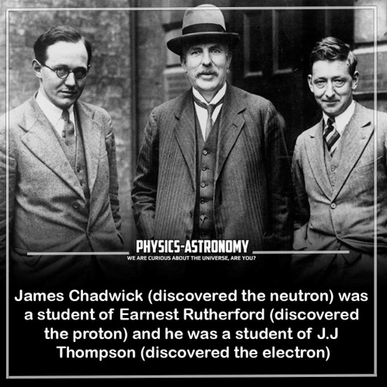
How might radiation (which is in the air all around us) lead to lung cancer?

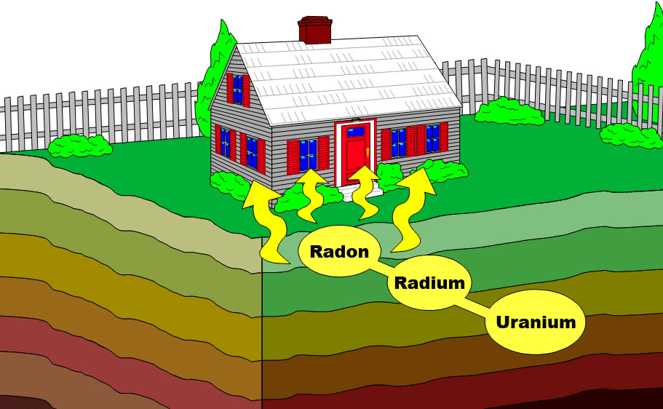


Radon gas (mainly from granite rock) is the main source of background radiation, which in turn is responsible for almost all the radiation we get exposed to over our lifetime. The problem occurs when we breathe in; some of the radioactive atoms in the gas undergo radioactive decay and emit alpha, beta or gamma radiation. These in turn can collide with and ionise atoms in our lung tissue, which can damage our DNA in the tissue of the cells, which could ultimately lead to lung cancer.
See epa.ie/environment-and-you/radon/radon-map/ for a map of Ireland’s high radon areas.

Does any increase in exposure to radiation cause an increase in the risk of getting cancer?
Short answer: We don’t know.

Long answer:
There is no dispute that radiation can cause DNA damage and that such damage is an initiating event in cancer development. Single-strand breaks are easily repaired however while studies have shown that this is not the case with double-strand breaks.

The linear no-threshold (LNT) theory assumes that any exposure to radiation carries a risk of developing cancer. It is widely applied by radiological protection agencies and endorsed by the International Commission on Radiological Protection (ICRP).
On the other hand breaks in the genetic code inside the cell are commonplace and quickly repaired. On average there are up to 150,000 breaks per cell daily. We already have a background of DNA breaks and any contribution to this total by radiation may be minor or indeed negligible.
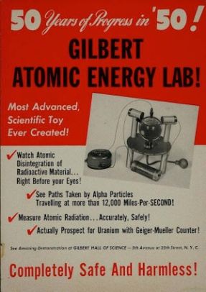

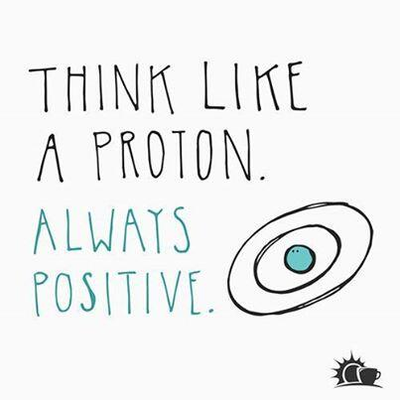

SLOP

The atom
Describe what was observed in Rutherford’s gold foil experiment. | Most alpha particles passed straight through; some were deflected by various amounts and a small percentage bounced back completely.
Why was it necessary to carry out that experiment in a vacuum? | To prevent the alpha particles colliding with other particles.
What conclusion did Rutherford form about the structure of the atom? | It consists of a small, dense, positively charged core with negatively charged electrons circling around it.
What is the structure of an alpha particle? | An alpha particle is identical to a helium nucleus (composed of 2 protons and 2 neutrons).
Describe the Bohr model of the atom. | A dense positively-charged nucleus with the negatively-charged electrons in orbit at specific (discrete) levels around it.
Describe how an emission line spectrum is produced. | When the gas is heated the electrons in the gas ‘jump’ up to higher orbital level and as they fall back down they emit electromagnetic radiation of a specific frequency.
When the toaster is on, the coil emits red light.  Explain, in terms of movement of electrons, why light is emitted when a metal is heated. | Electrons gain energy and jump to higher energy. Then when they fall back down they emit electromagnetic radiation in the form of light.
What is an isotope? | Isotopes are atoms which have the same atomic number but different mass numbers.
Give two examples of radioisotopes. | Iodine, caesium, radon, carbon 14, etc.
How many neutrons are in a ¹⁴C nucleus? | Eight
Radioactivity
What is radioactive decay? | Radioactive decay is the breakup of unstable nuclei with the emission of one or more types of radiation.
What is radioactivity? | Radioactivity is the breakup of unstable nuclei with the emission of one or more types of radiation.
Name the three types of radiation. | Alpha (α), beta (β) and gamma (γ).
Which radiation is negatively charged? | Beta (β)
Which radiation has the shortest range? | Alpha (α)
Which radiation is not affected by electric fields? | Gamma (γ)
Name the French physicist who discovered radioactivity in 1896. | Henri Becquerel (you shouldn’t have been asked this).
What is measured in becquerels? | Rate of decay / activity of a radioactive substance.
Apart from “carbon dating”, give two other uses of radioactive isotopes. | Medical imaging, (battery of) heart pacemakers, sterilization, tracers, irradiation of food, killing cancer cells, measuring thickness, smoke detectors, nuclear fuel, detect disease, detect leaks.
Give two examples of radioisotopes. | Iodine, caesium, radon, carbon 14, etc.
Name an instrument used to detect radiation/ alpha particles/ measure the activity of a sample. | Geiger Muller tube.
What is the principle of operation of this instrument? | Incoming radiation causes ionisation of the gas.
Give two uses of a radioactive source. | Carbon dating, radiotherapy, sterilising medical equipment, killing bacteria in food, smoke alarm
Give two effects of radiation on the human body. | Cancer, skin burns, sickness, cataracts, cause sterility, genetic, etc
Radioactivity causes ionisation in materials. What is ionisation? | Ionisation occurs when a neutral atom loses or gains an electron.
What is ionising radiation? | Electromagnetic radiation which has sufficiently high frequency/energy to cause ions to form.
Give examples of ionising radiation. | Ultra-violet radiation, x-ray radiation, gamma radiation
How does radiation cause cancer? | It ionises atoms/molecules in the dna. The host cell may not work properly anymore and when the cell replicates over and over it can eventually develop into a tumour.
Why is non-ionising radiation considered not to be as dangerous as ionising radiation? | It doesn’t ionise atoms so has little if any effect on cells.
Is mobile phone radiation ionising or non-ionising? | Non-ionising
Describe an experiment to demonstrate the ionising effect of radioactivity. | Apparatus: radioactive source and charged (gold leaf) electroscope  Procedure: bring radioactive source close to the cap  Observation: leaves collapse  Conclusion: charge leaks away through ionised air / electroscope neutralised by ionised air
Half-life
Explain the term half-life. | Time for half the radioactive nuclei in a sample to decay
What is meant by background radiation? | Radiation which is in the environment due to rocks/cosmic radiation.
Name the naturally occurring radioactive gas which seeps into buildings from underground rocks and which can cause lung cancer. | Radon (gas)
Give two precautions that are taken when storing the plutonium / dealing with radioactive sources. | Use thick shielding, use a tongs, use protective clothing, etc.

3: Fission, fusion and nuclear energy

We made the mistake of lumping nuclear energy in with nuclear weapons, as if all things nuclear were evil. I think that’s as big a mistake as if you lumped nuclear medicine in with nuclear weapons.
Patrick Moore, former Director of Greenpeace International.
Imagine - we could have avoided our own extinction.

Student notes

Nuclear fission
Nuclear fission is the break-up of a large nucleus into two smaller nuclei with the release of energy and neutrons.

Nuclear fission | Example: fission of uranium-235
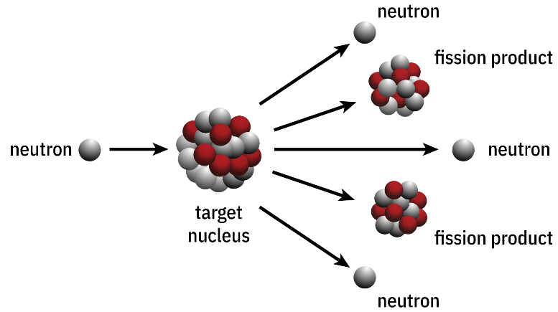 | 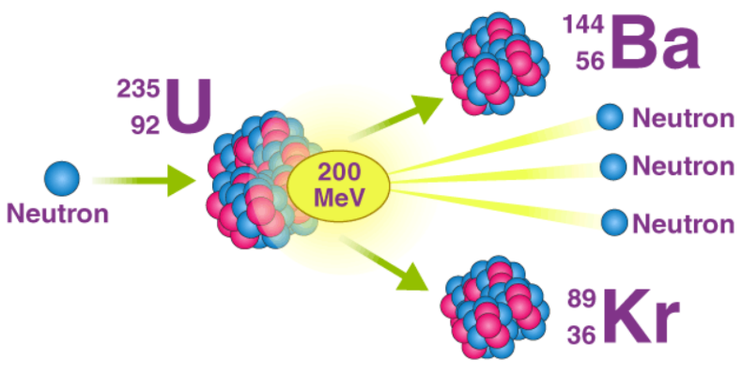
I like the diagram on the right. Many diagrams will will just say ‘energy’ as if a bunch of energy is moving off by itself whereas what is actually happening is that this energy will be in the form of kinetic energy associated with the fast moving daughter particles.

Example
Natural uranium is made up of two isotopes: ²³⁵U (0.7%), and ²³⁸U (99.3%).
Only U-235 undergoes fission. This occurs if it is bombarded with fast-moving or slow-moving neutrons, but is more likely to occur if the neutrons are relatively slow moving.

This reaction is represented as follows:
$${}_{92}^{235}U+{}_{0}^{1}n → {}_{56}^{141}{Ba}+{}_{36}^{92}{Kr}+3{}_{0}^{1}{n+K. E.}$$

The neutrons produced are fast moving (as represented by the K.E. term above) and may trigger further fission.
But to acquire this energy some of the original mass had to ‘disappear’. This ‘missing mass’ can be calculating by finding the total mass before and after the reaction and subtracting one from the other.
The energy associated with this missing mass can then be calculated using E = mc².
We will practice lots of these maths questions shortly.

Nuclear fission equations - exam questions

2008 Question 12 (c) [Higher Level]
U–238 undergoes fission when struck by a slow neutron. Barium–139 and krypton–97 nuclei are emitted along with three neutrons.
Write a nuclear reaction to represent the reaction.

2014 Question 8 [Higher Level]  Plutonium is produced in a fission reactor when one of the neutrons released in the fission reaction converts uranium–238 into plutonium–239 with the emission of two beta-particles.  Write an equation for this nuclear reaction. | $$U_{92}^{238}+n_{0 }^{1}→ {Pu}_{94}^{239}+ 2β_{-1}^{0}$$
2018 Question 8 [Higher Level]  In a fission reaction a neutron is absorbed by a uranium–235 nucleus. Barium–139 and krypton–94 nuclei are released as well as some neutrons.  Write a nuclear equation for this reaction. | $${}_{92}^{235}U+{}_{0}^{1}n → {}_{56}^{141}{Ba}+{}_{36}^{92}{Kr}+3{}_{0}^{1}{n+K.E.}$$
2020 question 10 [Higher Level]  Is nuclear fission a spontaneous or a non‐spontaneous process? Explain your answer. | Non‐spontaneous because a neutron is required to initiate the process.

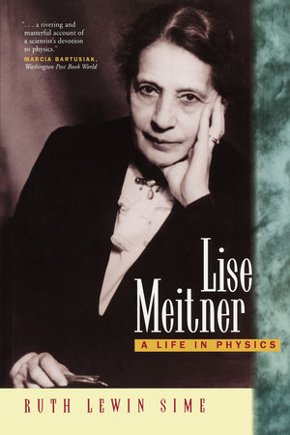
Remember the story of Dame Jocelyn Bell Burnell and how she was overlooked when it came to the awarding of the Novel Prize for the discovery of quasars? Lise Meitner had a similar story. Meitner was working with her colleague Otto Hahn on atomic physics Hahn published their explanation of nuclear fission in the prestigious Nature journal in 1939 but failed to mention Meitner. As a result Hahn was awarded the1944 Nobel Prize in Chemistry. Although this discovery eventually lead to the atomic bomb (via the Manhattan Project) Meitner (who was Jewish herself) declared “I will have nothing to do with a bomb.”
She was also scathing of Heisenberg and his decision to remain in Germany to work on their own version of the atomic bomb (which fortunately never got anywhere). “Heisenberg and many millions with him should be forced to see these camps and the martyred people,” she wrote. The element meitnerium is named after her and her epitaph simply reads: “Lise Meitner: a physicist who never lost her humanity.”

Nuclear energy: E = mc²

Listen. No seriously. Listen. The most famous equation in the world is E = mc². For most people alive today it is the only maths equation that they know, even if they have absolutely no idea what it actually means. But the unfortunate aspect to this is that they also think that there’s no point even trying to figure out what it means because, well, Einstein. And stuff. But they’re wrong. It is remarkably easy to understand E = mc². If you’re able to follow Harry Potter then you’re able to understand E = mc², it’s that simple.

To fully appreciate what’s going on you should NEVER say that mass gets converted to energy. Because that is to imply that mass was never energy to begin with – and that would be wrong. Sound is form of energy, light is a form of energy, heat is a form of energy, mass is a form of energy. And that’s it. We’re all happy that electrical energy can be converted to sound energy (this is what a speaker does – the electrical energy ‘disappears’ and is re-manifests as sound energy) and that light energy can be converted to electrical energy (electrical energy ‘disappears’ and re-manifests as electrical energy) and we have equations to tell us how much energy is involved in each case. And that’s all that’s going on with E = mc². The equation tells us the amount of energy that is converted into other forms when mass energy disappears.
Now that’s not to take away from the novel nature of this concept. After all even Einstein refers to it as ‘a somewhat unfamiliar conception for the average mind’. Unfortunately the poor phrasing associated with ‘mass is converted to energy’ is now way too widespread for it to change at this stage (even Einstein uses that terminology, as do many of the exam questions below). But you? You know better. And now you understand E = mc². You’re welcome. Go forth and spread the good news.

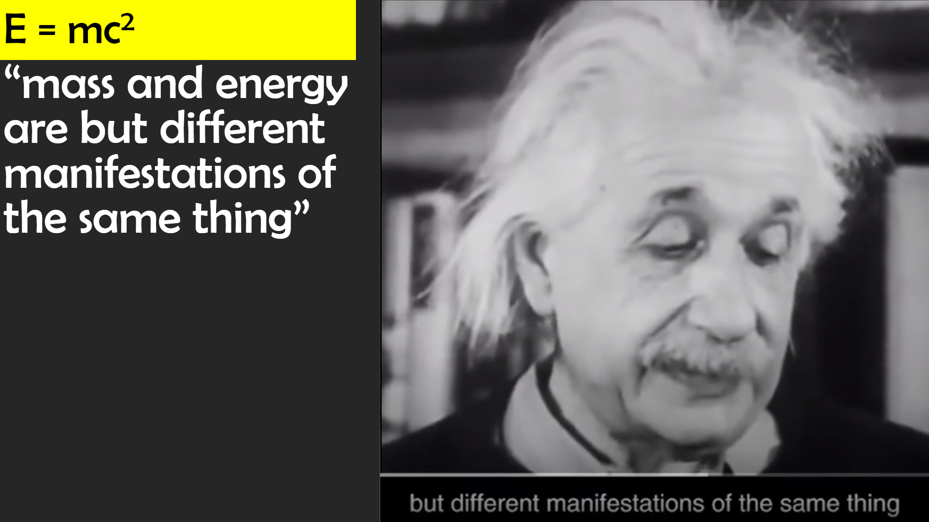 |  | 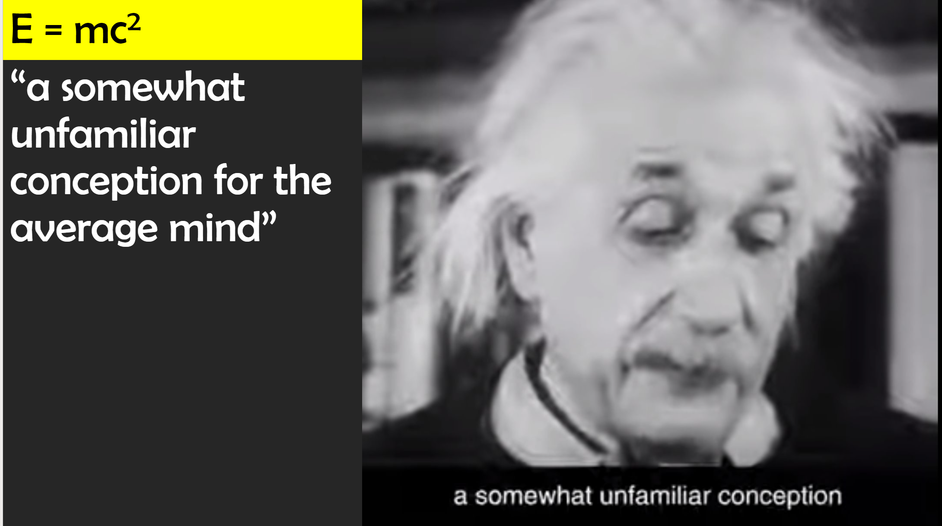

Albert’s mathematical ability
2014 Question 5 [Ordinary level]  In the Sun, a mass of 4 × 10⁹ kg is converted into energy every second.  Calculate the energy released each second. | Solution  m = 4 × 10⁹ kg  c= speed of light = 3 × 10⁸ m s⁻¹  E = mc² = (4× 10⁹)(3 × 10⁸)² = 3.6 × 10²⁶ J  See footnote below for more on the significance of this number.

Atomic mass units
The key to each of the exam questions below is to realise that some of the mass energy from the left hand side of the equation has been converted into kinetic energy of the daughter particles on the right hand side, and to calculate how much energy has been converted or ‘released’ we simply subtract the total mass on the right from the total mass on the left and then use E = mc².
See footnote below for more information on the source of this missing mass

But when using E = mc² we have to make sure that the mass is in kilograms (kg).

The mass of atomic particles are incredibly small relative to the kilogram so physicists use a much smaller unit called the atomic mass unit (a.m.u.).
The unit for atomic mass unit is u. 1 u = 1.660 5402 × 10⁻²⁷ kg

This conversion factor can be found on page 47 of the F&T booklet.

Using the Formula & Tables book to find the mass of atoms (in atomic mass units): pages 83 - 90

Sometimes the exam questions will give us all the masses in kg but if not then we need to go to the F&T book to find that information. And that’s when the fun really begins.
Pages 83 – 90 supply the mass of atoms in terms of atomic mass units so you will also need page 47 which gives the mass of an atomic mass unit in kg which allows you to convert from atomic mass units to kilograms.

The term ‘nuclides’ below is confusing as we have never come across it before. Nuclides are atoms grouped by atomic number – not to be confused with nuclei (the plural of nucleus). The mass of nuclides incorporates the protons, neutrons and electrons). So for example if you want to find the mass of an alpha particle you need to go to page 46 where it mentions it explicitly in kg. Do NOT take it from the page below as that number includes the mass of the associated electrons.

Note that the half-lives are also listed here. I’m surprised that information from this column has never been required (to date).

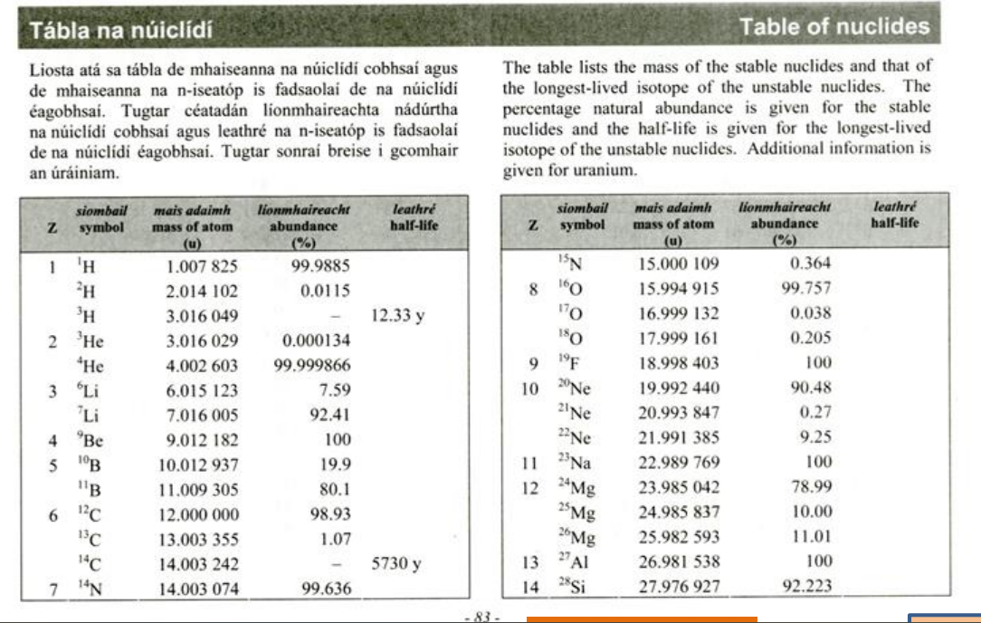

For each of the examples below the total mass on the left-hand side is greater than the total mass on the right-hand side.
The mass which has disappeared re-manifests itself as kinetic energy of the particles on the right.
2006 Question 8 [Higher Level]
Controlled nuclear fusion has been achieved on earth using the following reaction:
$${}_{1}^{2}{H+ {}_{1}^{3}H}→ {}_{2}^{4}{He+{}_{0}^{1}n}$$
Calculate the energy released during this reaction.

speed of light = 2.998 × 10^{–8} m s^{–1}; mass of hydrogen-2 nucleus = 3.342 × 10^{–27} kg ;
mass of hydrogen-3 nucleus = 5.004 × 10^{–27} kg; mass of helium nucleus = 6.644 × 10^{–27} kg;
mass of neutron = 1.674 × 10^{–27} kg
Solution
Mass beforehand = mass of hydrogen-2 nucleus + mass of hydrogen-3 nucleus
= 3.342 × 10^{–27} kg + 5.004 × 10^{–27} kg
= 8.346 x 10⁻²⁷ kg

Mass after = mass of helium nucleus + mass of neutron
= 6.644 × 10^{–27} kg + 1.674 × 10^{–27} kg
= 8.318 × 10⁻²⁷ kg
Loss in mass /defect mass = (8.346 x 10⁻²⁷) – (8.318 × 10⁻²⁷) = 2.8 × 10⁻²⁹ kg

E = mc² E = (2.8 × 10⁻²⁹)( 2.998 × 10⁸)² E = 2.52 × 10⁻¹² J

2016 Question 9 [Higher Level]
The following is the nuclear equation of a fission reaction explained by Meitner.

$${}_{92}^{238}{U+ }{}_{0}^{1}{n → {}_{56}^{139}{Ba}}+ {}_{36}^{97}{Kr}+3{}_{0}^{1}n$$

Calculate the energy released during this reaction.
Nuclear masses: U–238 = 3.9529 ×10^{–25} kg; Ba–139 = 2.3066 ×10^{–25} kg; Kr–97 = 1.6099 ×10^{–25} kg
mass of neutron =1.674 927 28 × 10^{–27} kg
Solution
Mass before = mass of uranium nucleus + mass of neutron
= 3.9529 × 10^{–25} + 1.674 927 28 × 10^{–27}

Mass beforehand = 3.9696 × 10^{–25} kg

Mass after = mass of barium nucleus + mass of krypton nucleus + mass of 3 neutrons
= 2.3066 × 10^{–25} kg + 1.6099 × 10^{–25} kg + 3(1.674 927 28 × 10^{–27})

Mass after = 3.9667 × 10^{–25} kg

Loss in mass = total mass beforehand – total mass afterwards
= (3.9696 × 10^{–25}) – (3.9667 × 10^{–25})
= 2.9 × 10^{–28} kg

E = mc²
Energy released = (2.9 × 10^{–28})(2.998 × 10⁸)²

E = 2.6 × 10^{–11} J

2012 Question 8 [Higher Level]
Energy can be produced in a fusion reaction by combining a deuterium and a tritium nucleus as follows:
$${}_{1}^{2}{H+ {}_{1}^{3}H}→ {}_{2}^{4}{He+n+energy}$$

How much energy is produced when a deuterium nucleus combines with a tritium nucleus?

Solution
As with previous questions, we need to calculate the total mass beforehand and the total mass afterwards and then subtract to find the mass defect. But the masses of the nuclides are only given in terms of their atomic mass unit so we need to convert to kg before using E = mc². We can convert all masses to kg at the beginning, then calculate loss in mass then use E = mc² or we can leave the masses in a.m.u. before calculating the loss in mass and only then convert to kg. This method is usually a little shorter – unless there is a neutron involved, because the mass of the neutron will obviously need to be in a.m.u. also ironically it is only listed in kg (1.67492728 × 10⁻²⁷ kg from page 46 of F&T booklet). So we need to multiply this by 1.660 5402 × 10⁻²⁷ kg (value of 1 a.m.u) to convert it to u to get a value for the mass of the neutron as 1.008672 u

$${}_{1}^{2}H + {}_{1}^{3}{H → {}_{2}^{4}{He}} + {}_{1}^{1}{n + energy}$$

2.014102 + 3.016049 → 4.002603 + 1.008672 + energy

5.030151 → 5.011275 + energy

Loss in mass = 0.018875 u

0.018875 u = ( 0.018875)(1.660 5402 × 10⁻²⁷) kg = 3.1344 × 10⁻²⁹ kg

E = mc² = (3.1344 × 10⁻²⁹)(3 × 10⁸)² = 2.82096 × 10⁻¹² J

2019 Question 11 [Higher level]
A plutonium–239 nucleus undergoes fission when a neutron collides with it.
Xenon–134 and zirconium–103 are produced together with some neutrons.
- Write a nuclear equation for this fission reaction.
- Calculate the energy released in this reaction.

Solution
$${}_{94}^{239}{Pu+ {}_{0}^{1}n→{}_{54}^{134}{Xe+{}_{40}^{103}{Zr}}+3{}_{0}^{1}n}$$

Masses: Pu–239 = 239.052163 u, Xe–134 = 133.905395 u, Zr–103 = 102.926599 u)
Neutron mass = 1.67492728 × 10⁻²⁷ kg

Here we convert everything into kg straight away just to show that this method is equally valid.

Total mass beforehand |  |  | Total mass afterwards
Pu–239 | 1 neutron |  | Xe–134 | Zr–103 | 3 neutrons
239.052163 u |  |  | 133.905395 u | 102.926599 u
3.96996 × 10⁻²⁵ | 1.67493 × 10⁻²⁷ |  | 2.22355 × 10⁻²⁵ | 1.70914 × 10⁻²⁵ | 5.02478 × 10⁻²⁷
3.9867093 × 10⁻²⁵ kg |  |  | 3.98294 × 10⁻²⁵ kg
Loss in mass = 3.7715 × 10⁻²⁸ kg
E = mc² = (3.7715 × 10⁻²⁸)(2.9979 × 10⁸)²
E = 3.3896× 10⁻¹¹ J

“Calculate the energy released” is a strange way of putting it. I would prefer something like “Calculate the amount of mass energy that is converted to kinetic energy in this reaction” but like I mention elsewhere it’s not easy to find the right combination of words to describe what goes on in these reactions.

Living with Albert

2021 Question 11 [Higher Level]
James Chadwick discovered the neutron in 1932. In his experiment an alpha particle was absorbed by a beryllium–9 nucleus and a neutron was emitted.

  - Write the nuclear equation for this event.
  - Calculate the increase in kinetic energy during this event.
Write the nuclear equation for this event.
$${Be}_{4}^{9}+{He}_{2}^{4}→C_{6}^{12}+n_{0}^{1}$$
Calculate the increase in kinetic energy during this event.

Total mass beforehand:
$${Be}_{4}^{9}+{He}_{2}^{4}$$

To find mass of Beryllium-9 nuclide$({Be}_{4}^{9})$ in kg:
Mass of beryllium-9 nuclide = 9.012182 u = (9.012182)(1.6605402×10⁻²⁹) kg = 1.49650905×10⁻²⁶ kg

Mass of alpha particle${(He}_{2}^{4})$ = (4.002603)(1.6605402×10⁻²⁹) = 6.646483186×10⁻²⁷ kg

Total mass beforehand = 1.49650905×10⁻²⁶ + 6.646483186×10⁻²⁷ = 2.161157369×10⁻²⁶ kg

Total mass afterward:
$$C_{6}^{12}+n_{0}^{1}$$

Mass of carbon 12 nuclide = 12 u = (12)(1.6605402×10⁻²⁹) kg = 1.99264824×10⁻²⁷ kg

Mass of a neutron = 1.67492728×10⁻²⁹ kg {given directly on page 46 of F&T booklet}

Total mass afterward: 1.99264824×10⁻²⁷ kg + 1.67492728×10⁻²⁹ kg = 2.160140968 × 10⁻²⁶ kg

Loss in mass = 2.161157369×10⁻²⁶ kg – (2.160140968 × 10⁻²⁶ kg) = 1.016401×10⁻²⁹ kg

Now we use E = mc²

E = (1.99264824×10⁻²⁷)(2.99792458×10⁸)² = 9.13 × 10⁻¹³ J

Chain reactions

If the mass of the sample is above a certain critical mass, the process will become self-sustaining (as a result of the new neutrons colliding into more uranium atoms) and a chain reaction will occur.

A chain reaction is a self-sustaining reaction where fission neutrons go on to produce further fission (giving more neutrons) etc.

If the mass is below the critical mass the reaction will simply fizzle out.

This process also occurs in a nuclear reactor, but at a controlled rate.

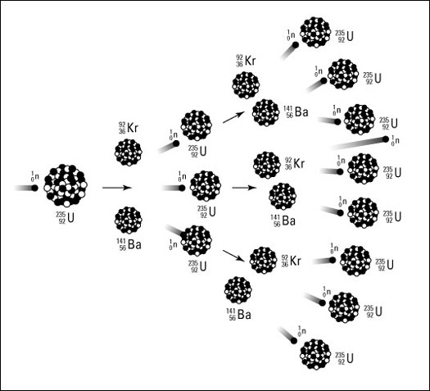

Nuclear reactors

Reactor plus heat exchanger | Inside the nuclear reactor
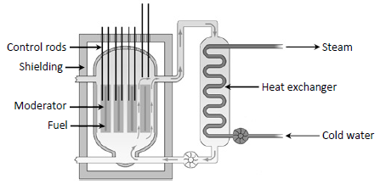

- The fuel is natural uranium.
- The moderator is graphite or heavy-water
This slows down the fast moving neutrons to enable further fission in ²³⁵U rather that being absorbed in ²³⁸U.
- The control rods absorb neutrons; they look like sleeves.
Lowering them over the fuel rods prevents the neutrons from one fuel rod reaching the next rod, and so they control the rate of the reaction. Lowering them completely causes the reaction to stop.
- A heat exchanger is a device that allows heat from the hot radioactive coolant to pass to another series of pipes containing water without having to mix together. This turns the water into steam which then goes on to power a turbine.

Environmental impact of fission reactors
Positive: No CO₂ emissions (apart from when it’s being built).
Negative: Radioactive waste, potential for major accidents.

Nuclear fusion
“Romantically, you could say that we are all made of stardust, but the truth is also that we're all just nuclear waste”. Jim Al-Khalili.
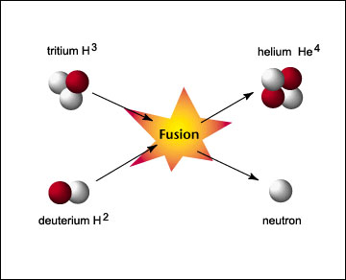
Nuclear fusion is the combining of two small nuclei to form one large nucleus with the release of energy.

Example
$${}_{1}^{2}H+{}_{1}^{3}{H→{}_{2}^{4}{He}}+{}_{1}^{1}n$$
${}_{1}^{2}H$ = deuterium (one proton plus one neutron)
${}_{1}^{3}H$ = tritium (one proton plus two neutrons)

2006 Question 8 [Higher Level]  In the sun 2 isotopes of helium, each with a mass number of 3, combine to form another isotope of helium with the release of 2 protons.  Write an equation for this nuclear reaction. | ${}_{2}^{3}{He}+{}_{2}^{3}{He}$→${}_{2}^{4}{He+2{}_{1}^{1}H}$

Why is a fission reactor a more viable source of energy than a fusion reactor?
- Easier to initiate a fission reaction
- Fission reactors can be more easily controlled

So why don’t we have fusion reactors producing electricity for us now (instead of fission reactors)?
The nuclear reaction involves the combination of 2 positively charged particles. To overcome this coulombic repulsion (remember Coulomb’s Law?) a large amount of energy must be supplied which makes it very difficult to control. This is why we have nuclear fusion bombs but not nuclear fusion generating stations.

Advantage of fusion over fission:
- Less radioactive waste.
- The raw material for fusion reactions (deuterium) is readily available from the oceans.
- No dangerous chain reactions.

2014 Question 8 [Higher Level]
Plutonium is produced in a fission reactor when one of the neutrons released in the fission reaction converts uranium–238 into plutonium–239 with the emission of two beta-particles.
Each fission of a uranium–235 nucleus produces 202 MeV of energy.
Only 35% of this energy is used to generate electricity.
How many uranium–235 nuclei are required to undergo fission to generate a constant electric power of 1 GW for a day?

Solution
Each nucleus that underdoes fission produces (202 ×10⁶) eV of energy, or
(202×10⁶)(1.6×10^{–19}) = 3.23×10^{–11} joules of energy. {1 eV = 1.6×10^{–19} J}
Efficiency is 35%, so 35% of 3.23 × 10^{–11} J = 1.13 × 10^{–11} J
1GW = 1 × 10⁹ W = 1×10⁹ joules per second {1 watt = 1 joule per second}
1 GW for a day = (1×10⁹)(60)(60)(24) joules
= 8.64×10¹³ J

So we need 8.64 × 10¹³ joules, and each nucleus produces 1.13 × 10^{–11} joules of useable energy.
So total number of nuclei required = $\frac{{8.64 × 10}^{13}}{{1.13 × 10}^{-11}}$ = 7.65 × 10²⁴ nuclei

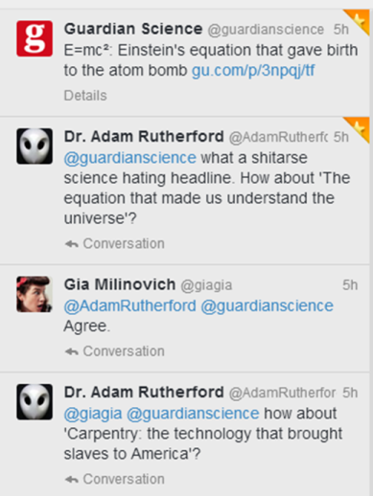
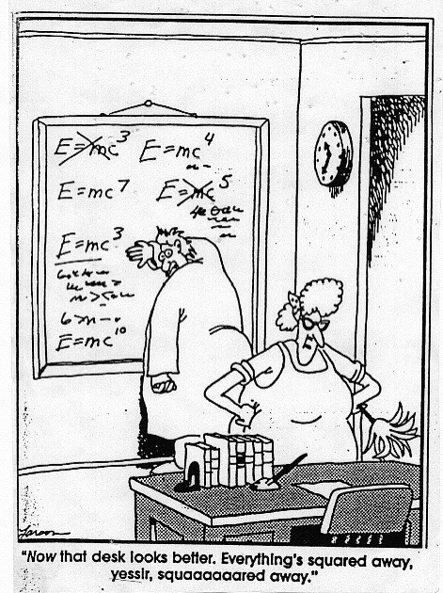
Background reading

Abortions in Greece, January 1987
As soon as the Chernobyl accident on 26th of April, 1986 was reported in newspapers and on TV, the actual events (initial deaths at the power plant turned out to be 31: fire-fighters and plant workers) rapidly became magnified in several countries and guesses by reporters were wildly inaccurate. Thus in the United Kingdom the Daily Mirror on 30 April headlined ‘Please get me out Mummy’, ‘Terror of trapped Britons’ and ‘2000 are feared dead in Nuclear Horror’. The Detroit Medical News of 12 May stated ‘So the Russians have started to self-distruct. That is the good news, the bad news is that they are exporting their fall-out across the globe.’ The New York Post was most outlandish with ’15,000 Dead in Mass Grave’. TV was not always much better with an American TV network buying for 20,000 US dollars a video purporting to be Chernobyl burning. Unfortunately for them, the views were recognised by Italians as being those of a fire at a Trieste cement factory. An ABC TV newscaster was reported to have said ‘It is one mistake we will try not to make again.’
The more horrific an accident, the ‘better news’ it is supposed to make, and this will not alter. I even found this attitude when trying to find a publisher for my book Chernobyl – The Real Story. I believe that I quite rightly claimed that the contents included ‘dramatic pictures’. However, one publisher rejected this claim because, as he said, ‘there were no pictures of dead bodies with legs and arms missing’.

In the aftermath of this incident at Chernobyl, the panic caused by incorrect and inadequate available information was particularly poignant in Greece. Pregnant mothers, because of the ‘scare’, had otherwise wanted pregnancies terminated. The expected number of live births in Greece in January 1987 was some 9,000 but in practice, there were only some 7,000 live births, a 23% reduction in those expected. This is considered by Greek Physicians to be virtually entirely due to the worry concerning the accident and this is corroborated by the number of live births in February and March 1987 being as expected, since for the births expected in these months, relevant information on radiation effects from Chernobyl was available to the Greek physicians and obstetricians.
References:
R F Mould 1988 Chernobyl – The Real Story (Oxford: Pergamon Press Ltd)
D Trichopoulos 1988 Victims of Chernobyl in Greece British Medical Journal 295 1100

Extract from a book entitled Mould's Medical Anecdotes

SLOP

Speed of light = 2.998 × 10⁻⁸ ms⁻¹; mass of hydrogen-2 nucleus = 3.342 × 10⁻²⁷ kg
Mass of hydrogen-3 nucleus = 5.004 × 10⁻²⁷ kg; mass of helium nucleus = 6.644 × 10⁻²⁷ kg;
Mass of neutron = 1.674 × 10⁻²⁷ kg
What is meant by nuclear fission?

Name a material in which fission occurs. | Uranium, Plutonium.
U–238 undergoes fission when struck by a slow neutron. Barium–139 and krypton–97 nuclei are emitted along with three neutrons.
Write a nuclear reaction to represent the reaction.
What type of nuclear reaction occurs in a nuclear power station? | Fission
Name five parts of a nuclear fission reactor. | Fuel rods, control rods, shielding, moderator, coolant.
Give the function of each of th parts of a nuclear fission reactor. | Fuel rod: source of energy  Control rod: controls the speed of the reaction by absorbing neutrons  Moderator: slows down neutrons  Heat exchanger: transfers heat energy  Shielding: prevent radiation escaping
Name a fuel used in a nuclear reactor. | Plutonium or uranium.
What is the role of neutrons in nuclear fission? | To make the nucleus unstable which causes fission.
Why are the neutrons slowed down? | Only slow neutrons can cause (further) fission.
How are fast neutrons slowed down? | They collide with the molecules in the moderator.
In a nuclear reactor, how can the fission be controlled or stopped? | Dropping the control rods absorbs the neutrons and prevents further fission.
How do cadmium rods control the rate of fission? | They absorbed neutrons which would otherwise cause fission.
Describe what happens to the coolant when the reactor is working. | It gets hot.
Name a material used as shielding in a nuclear reactor. What is a chain reaction? | It is a self-sustaining reaction where fission neutrons go on to produce further fission (giving more neutrons) etc.
Give one condition necessary for a chain reaction to occur. | The mass of fuel present must exceed the critical mass / at least one of the neutrons released must cause fission of another nucleus.
Describe how a chain reaction occurs in the fuel rods. | A neutron is fired into the material and this splits the nucleus of one of the atoms releasing more energy and neutrons. This process then continues.
Explain how the chain reaction is controlled. | The control rods can move up and down and when they are lowered they absorb the neutrons which prevents further fission.
How is the energy produced in a nuclear reactor used to generate electricity? | The energy produced is converted to heat. This is used to generate steam which drives a generator.
Give one advantage and one disadvantage of a nuclear reactor as a source of energy. | Advantage; abundant fuel / cheap fuel / no greenhouse gases / no global warming , etc.  Disadvantage; risk of nuclear contamination / fallout / difficulty of dealing with waste / dangerous, etc.
Name three types of radiation that are present in a nuclear reactor. | - Alpha, beta and gamma.
Give one effect of a nuclear fission reactor on the environment. | - It can cause pollution due to nuclear waste.
Fission reactors are being suggested as a partial solution to Ireland’s energy needs.  Give one positive and one negative environmental impact of fission reactors. | Positive: no CO₂ emissions / no greenhouse gases / no gases to result in acid rain / less dependence on fossil fuels.  Negative: radioactive waste / exposure to radiation / potential for major accidents etc.
Distinguish between radioactivity and fission. | Radioactivity is the breakup of unstable nuclei with the emission of one or more types of radiation.  Nuclear Fission is the break-up of a large nucleus into two smaller nuclei with the release of energy (and neutrons).
Give an application of fission. | Generating electrical energy, bombs
Give one precaution that should be taken when storing radioactive materials. | Store in lead or use a tongs when handling.
In Einstein’s equation E = mc², what does c represent? | The speed of light.
100 MJ of energy are released in a nuclear reaction. Calculate the loss of mass during the reaction. | E = mc² m = E/c²  m = (1 × 10⁸) / (9 × 10¹⁶) = 1.11 × 10⁻⁹ kg.
Distinguish between fission and fusion. | Nuclear fission is the break-up of a large nucleus into two smaller nuclei with the release of energy (and neutrons).  Nuclear fusion is the combining of two small nuclei to form one large nucleus with the release of energy.
At present, why is a fission reactor a more viable source of energy than a fusion reactor? | Easier to initiate reaction, fission can be more easily controlled.
What is the source of the sun’s energy? | Nuclear fusion
How does the sun produce heat and light? | Through nuclear reactions.
Why are large temperatures required for fusion to occur? | Nuclei are positively charged so enormous energy is required to overcome the very large repulsion.
Give one benefit of a terrestrial fusion reactor under each of the following headings:  - fuel; (b) energy; (c) pollution. | Fuel: plentiful / cheap  Energy: vast energy released  Pollution: little (radioactive) waste / few greenhouse gases  Very large energy/temperature is necessary.

Atomic physics Exam Questions 2002 - 2022

Structure of the atom Ordinary Level
2008 Question 10 [Ordinary Level]
Give two properties of an electron.
The diagram shows the arrangement used by Rutherford to investigate the structure of the atom. During the investigation he fired alpha-particles at a thin sheet of gold foil in a vacuum.
- What are alpha-particles?
- Describe what happened to the alpha-particles during the experiment.
- What conclusion did Rutherford make about the structure of the atom?
- How are the electrons arranged in the atom?
- Name a device used to detect alpha-particles.
- Why was it necessary to carry out this experiment in a vacuum?

2011 Question 12 (d) [Ordinary Level]
The diagram shows the arrangement used to investigate the structure of the atom. During the investigation, alpha-particles were fired at a thin sheet of gold foil in a vacuum.
- What are alpha-particles?
- What happened to the alpha-particles in the experiment?
- What did the experiment reveal about the structure of the atom?
- Name the scientist who designed the experiment.
- Name a suitable detector of alpha-particles.

2015 Question 11 [Ordinary Level]
Read the following passage and answer the accompanying questions.
Ernest Rutherford (1871–1937, Nobel Prize 1908) was a brilliant student from New Zealand who, thanks to a grant, moved to the glorious Cavendish Laboratory in Cambridge, full of hopes and ambitions. Later in his life he became a physics professor at the University of Manchester.
One day in 1909, in Manchester, he suggested to his collaborator Hans Geiger and to his student Ernest Marsden that they study the deflection of the so-called alpha-particles. These are positively charged helium ions produced by a radioactive source of radium bromide. This deflection occurs when the alpha-particles pass through a thin film of gold. Experiments of this kind had already been performed, and it had been observed that the alpha-particles are only slightly deflected when they cross the film.
The novelty of Rutherford’s suggestion was that he asked his collaborators to check if any alpha-particle bounced back instead of going through the film. Why should a thin metal film reflect heavy high-speed bullets, like the alpha-particles produced by a radioactive source? Geiger and Marsden made their measurement and ran back breathlessly to Rutherford. They had observed that some alpha-particles were indeed bouncing back.
In Rutherford’s words: “It was quite the most incredible event that has ever happened to me in my life”. He had looked inside the atom and the image he saw was very different from what physicists had expected. A central nucleus, much smaller than the actual size of the atom, holds the entire positive charge and practically all the atomic mass. The rest is just a cloud of light electrons, carrying all the negative charge.
(Adapted from A Zeptospace Odyssey, Gian Francesco Giudice, Oxford University Press, 2010)
(a) What are alpha-particles?
(b) Name a source of alpha-particles.
(c) What material was used as the target in the experiment?
(d) How did Geiger and Marsden detect the alpha-particles?
(e) What was the surprising result they observed?
(f) What force caused the deflection of the alpha-particles?
(g) Outline what the Geiger-Marsden experiment revealed about the structure of the atom.
(h) For what invention is Hans Geiger most famous?

Structure of the atom and emission spectrums Higher Level

2002 Question 12 (d) [Higher Level]
- The diagram shows a simplified arrangement of an experiment carried out early in the 20th century to investigate the structure of the atom.
Name the scientist who carried out this experiment.
- Describe what was observed in this experiment.
- Why was it necessary to carry out this experiment in a vacuum?
- What conclusion did the scientist form about the structure of the atom?

2022 Deferred Question 8 [Higher Level]
- What is meant by the emission line spectrum of an element?
- How is the emission line spectrum of an element related to the energy levels of the electrons in an atom of that element?
- Describe how you would show the emission line spectrum of hydrogen in the laboratory.

2020 Question 11 [Higher level]

Read the following passage and answer the accompanying questions.
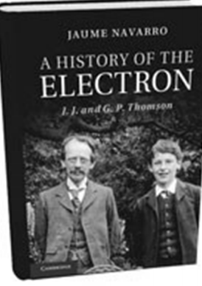
A History of the Electron
In 1897, J.J. Thomson ascribed particle nature to the carriers of electricity in cathode rays. This is traditionally known as the date of the discovery of the electron. Exactly thirty years later, his sonG.P. Thomson observed the first ever images of electron diffraction, with which he showed the wave‐like behavior of his father’s electrons.
Ironically, while his father had showed that a wave phenomenon (cathode rays) could be explained in terms of particles (electrons), the son was reclaiming wave characteristics for his father’s particles.
Soon after J.J. Thomson had found evidence of the atomicity of electric charges, physics began to move towards a more fundamental atomicity, that of energy. The age of quantum physics had begun.
In 1904, J.J. Thomson proposed the ‘plum pudding model’ of the atom. He considered the atom to ‘consist of a number of negatively charged corpuscles enclosed in a sphere of uniform positive charge’. In 1909, Geiger and Marsden conducted experiments with thin sheets of gold. Their professor, Ernest Rutherford, interpreted their results and improved Thomson’s model with his nuclear model of the atom. Later Niels Bohr, working with Rutherford in Manchester, expanded the nuclear model, proposing what is now known as the Bohr model. He had previously worked with J.J. Thomson in Cambridge.

Adapted from ‘A History of the Electron’, J.J. and G.P. Thomson (Jaume Navarro) Cambridge University Press 2019

  - J.J. Thomson used cathode ray tubes in his research. How are electrons (i) produced, (ii) deviated in a cathode ray tube?
  - Cathode rays are accelerated through a potential difference of 4 kV in a cathode ray tube.
Calculate the maximum speed of an electron in the tube.
  - What pieces of apparatus can be used to demonstrate the diffraction of light in the laboratory?
  - Geiger also played an important role in the development of the Geiger counter, a detector of nuclear radiation. Describe the principle of operation of any detector of nuclear radiation.
  - Describe the Geiger‐Marsden experiment that used thin sheets of gold. Include their setup, observations and conclusions.
  - Describe with the aid of a labelled diagram the Bohr model of the atom. Use the model to explain emission line spectra.

2017 Question 9 {first 2 parts only}
- Describe Rutherford’s experiment to investigate the structure of the atom.
- What conclusions about the nature of the atom did Rutherford make?

2021 Question 11 [Higher Level]
The photograph shown was taken during a meeting of the Deutsche Bunsen-Gesellschaft (German Bunsen Society) in 1932.
The three people sitting at the left of the table are James Chadwick, Hans Geiger and Ernest Rutherford. Lise Meitner and Otto Hahn are standing behind Rutherford. The careers of Chadwick and Geiger were very similar.
They both worked under Rutherford early in their careers. Later they were on opposite sides in the efforts to build the first nuclear bombs, Chadwick with the Manhattan Project in America and Geiger with the Uranium Club in Germany. Shortly before this photograph was taken, Chadwick had discovered the neutron.
In his experiment an alpha particle was absorbed by a beryllium–9 nucleus and a neutron was emitted.
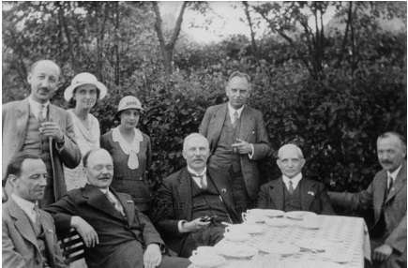
  - Write the nuclear equation for this event.
  - Calculate the increase in kinetic energy during this event.
  - Geiger is best remembered for co‐inventing the Geiger‐Müller tube.
A G‐M tube and a solid‐state detector have the same function. What is this function?
  - Describe, with the aid of a labelled diagram, the principle of operation of a detector of this sort.
  - While working with Rutherford, Geiger assisted on the gold foil experiment.
Describe with the aid of a labelled diagram the gold foil experiment.
  - What observations were made during the experiment?
  - What did Rutherford conclude about the structure of the atom?
  - How did Niels Bohr improve Rutherford’s model to explain emission line spectra?

Radioactivity Ordinary Level
2010 Question 12 (d) [Ordinary Level]
- What is radioactivity?
- The diagram shows a shielded radioactive source emitting nuclear radiation.
How do you know that the source is emitting three types of radiation?
- Name the radiation blocked by each material.
- Give one danger associated with nuclear radiation.
- State two precautions that should be taken when handling radioactive substances.
- Give two uses for radioactive substances

2004 Question 10 [Ordinary Level]
- What is radioactivity?
- Name the French physicist who discovered radioactivity in 1896.
- The diagram illustrates that three types of radiation are emitted from a radioactive source.
Name the radiations labelled (i) X, (ii) Y, (iii) Z, in the diagram.
- Which one is the most ionising?
- Name a detector of ionising radiation.
- Outline the principle on which the detector works.
- Great care has to be taken when dealing with radioactive sources.
Give two precautions that should be taken when dealing with radioactive sources.
- Give one use of a radioactive source.
- Give one harmful effect of radiation.

2011 Question 10 [Ordinary Level]

Radon is a radioactive gas which emits alpha particles. Radon gas comes into houses through gaps in the floors. Exposure to radon gas can cause lung cancer

- What is radioactivity?
- Name the other two types of radiation emitted by radioactive sources.
- Describe an experiment to distinguish between the three types of radiation.
- List three properties of one of these radiations.
- The most stable isotope of radon has a half-life of 4 days.
What are isotopes?
- Why is it important to prevent radon gas entering your home?
- If no more radon gas entered your home, how long would it be until one eight of the radon gas was left?
- Give two uses of radioisotopes.

2007 Question 11 [Ordinary Level]
Read this passage and answer the questions below. Radon is a naturally occurring radioactive gas. It originates from the decay of uranium, which is present in small quantities in rocks and soils. Radon is colourless, odourless and tasteless and can only be detected using special equipment, like a Geiger-Müller tube, that can measure the radiation it releases. Because it is a gas, radon can move freely through the soil and enter the atmosphere. When radon reaches the open air, it is quickly diluted to harmless concentrations, but when it enters an enclosed space, such as a house, it can sometimes accumulate to unacceptably high concentrations. Radon can enter a building from the ground through small cracks in floors and through gaps around pipes and cables. Radon is drawn from the ground into a building because the indoor air pressure is usually lower than outdoors. Being radioactive, radon decays releasing radiation.
When radon is inhaled into the lungs the radiation released can cause damage to the lung tissue.
(a) What is radioactivity?
(b) What is the source of radon?
(c) Name a detector of radiation.
(d) How does radon enter a building?
(e) How can the build-up of radon in the home be prevented?
(f) Why is radon dangerous?
(g) Why is radon harmless in the open air?
(h) Name a radioactive element other than radon.

2002 Question 11 [Ordinary Level]
The world’s most devastating nuclear accident happened at Chernobyl in the Ukraine in 1986. In the early hours of the morning of 26 April of that year, there were two loud explosions that blew the roof off and completely destroyed the No. 4 reactor, releasing during the course of the following days, 6 to 7 tonnes of radioactive material, with a total activity of about 10¹⁸ becquerels, into the atmosphere.
The discharge included over a hundred radioisotopes, but iodine and caesium isotopes were of main relevance from a human health and environmental point of view. Contamination in the surrounding areas was widespread, with the half-life of some of the materials measured in thousands of years.
Large numbers of people involved in the initial clean up of the plant received average total body radiation doses of about 100 mSv - about five times the maximum dose permitted for workers in nuclear facilities. Average worldwide total body radiation dose from natural ‘background’ radiation is about 2.4 mSv annually.
During, and soon after the accident and the initial clean-up, at least 30 plant personnel and firefighters died from burns and radiation. In the eight years following the accident, a further 300 suffered radiation sickness, and there are possible links between the accident and increased numbers of thyroid cancers in neighbouring regions.
(Adapted from “Physics – a teacher’s handbook”, Dept. of Education and Science.)

- What is meant by a nuclear accident?
- The No. 4 reactor was a fission reactor. What is nuclear fission?
- Name two parts of a nuclear fission reactor.
- What is measured in becquerels?
- Give two examples of radioisotopes.
- What is meant by the half-life of a substance?
- What is meant by background radiation?
- Give two effects of radiation on the human body.

2004 Question 10 [Ordinary Level]
- What is radioactivity?
- Name the French physicist who discovered radioactivity in 1896.
- The diagram illustrates that three types of radiation are emitted from a radioactive source.
Name the radiations labelled (i) X, (ii) Y, (iii) Z, in the diagram.
- Which one is the most ionising?
- Name a detector of ionising radiation.
- Outline the principle on which the detector works.
- Great care has to be taken when dealing with radioactive sources.
Give two precautions that should be taken when dealing with radioactive sources.
- Give one use of a radioactive source.
- Give one harmful effect of radiation.

Radioactivity Higher Level

2016 Question 12 (a) [Higher Level]
- State the principle of conservation of momentum.
- A polonium–212 nucleus decays spontaneously while at rest, with the emission of an alpha-particle.
What daughter nucleus is produced during this alpha-decay?

- The kinetic energy of the emitted alpha-particle is 8.9 MeV. Calculate its velocity.
- Calculate the velocity of the daughter nucleus after the decay.

Half-life Ordinary Level
2005 Question 12 (d) [Ordinary Level]
Na−25 is a radioactive isotope of sodium. It has a half life of 1 minute.
- What is meant by radioactivity?
- Name a detector of radioactivity.
- Explain the term half life.
- What fraction of a sample of Na−25 remains after 3 minutes?
- Give one use of a radioactive isotope.

Half-life Higher Level

2007 Question 12 (d) [Higher Level]
- Explain the term half-life.
- A sample of carbon is mainly carbon-12 which is not radioactive, and a small proportion of carbon-14 which is radioactive. When a tree is cut down the carbon-14 present in the wood at that time decays by beta emission.
Write a nuclear equation to represent the decay of carbon-14.
- An ancient wooden cup from an archaeological site has an activity of 2.1 Bq.
The corresponding activity for newly cut wood is 8.4 Bq.
If the half-life of carbon-14 is 5730 years, estimate the age of the cup.
- Name an instrument used to measure the activity of a sample.
- What is the principle of operation of this instrument?

2003 Question 11 [Higher Level]
Read the following passage and answer the accompanying questions.
Irish Times: Monday, January 11,1999
Radioactive decay helps to determine exact dates.
Radioactive decay occurs with such precision that it is often used as a clock.
Carbon dating has been invaluable to archaeologists, historians and anthropologists.
The method is based on the measurement of ¹⁴C, a radioactive isotope of carbon with a half-life of 5730 years. ¹⁴C occurs to a small extent in the atmosphere together with the much more common ¹²C.
Living organisms constantly exchange carbon with the atmosphere and the ratio of ¹⁴C to ¹²C in living tissue is the same as it is in the atmosphere.
This ratio is assumed to have remained the same since prehistoric times.
When an organism dies, it stops exchanging carbon with the atmosphere, and its ¹⁴C nuclei keep disintegrating while the ¹²C in the dead tissue remains undisturbed.
- What is radioactive decay?
- What is an isotope?
- Apart from “carbon dating”, give two other uses of radioactive isotopes.
- How many neutrons are in a ¹⁴C nucleus?
- ¹⁴C decays to ¹⁴N. Write an equation to represent this nuclear reaction.
- How much of a ¹⁴C sample remains after 11460 years?
- Calculate the decay constant of ¹⁴C.
- Why does the ¹²C in dead tissue remain “undisturbed”?
(Refer to the Periodic Table of the Elements in the Mathematics Tables, p.44.)

2009 Question 12 (d) [Higher Level]
Smoke detectors use a very small quantity of the element americium-241. This element does not exist in nature and was discovered during the Manhattan Project in 1944.
Alpha particles are produced by the americium-241 in a smoke detector.
- Give the structure of an alpha particle.
- How are the alpha particles produced?
- Why do these alpha particles not pose a health risk?
- Americium-241 has a decay constant of 5.1 × 10^{–11} s^{–1}.
Calculate its half life in years.
- Explain why americium-241 does not exist naturally.

2020 Question 8 [Higher level]
Radioactivity was discovered in 1896 by Henri Becquerel.
- Define radioactivity
- Define the becquerel.

In the uranium decay series, U–238 decays to Pb206 in a series of alpha and beta decays.
The first decay in this series is an alpha decay and the final decay is a beta decay.

- Write a nuclear equation for the first decay in this series.
- Write a nuclear equation for the final decay in this series.
- Calculate the total number of alpha particles and the total number of beta particles emitted in the series

The half‐life of U–238 is 4.5 × 10⁹ years.
- How long will it take for the number of U-238 nuclei in a sample to decrease by a factor of 8?
- A sample of U–238 contains 3.2 × 10¹⁰ nuclei. Calculate its activity.
- U-38 is an isotope of uranium. What are isotopes?

Radon gas forms part of the uranium decay series.
- Why is radon considered to be dangerous?
- How can the build-up of radon in a building be reduced?

2005 Question 8 [Higher Level]
Nuclear disintegrations occur in radioactivity and in fission.
- Distinguish between radioactivity and fission.
- Give an application of radioactivity.
- Give an application of fission.
- Radioactivity causes ionisation in materials. What is ionisation?
- Describe an experiment to demonstrate the ionising effect of radioactivity.
- Cobalt−60 is a radioactive isotope with a half-life of 5.26 years and emits beta particles.
Write an equation to represent the decay of cobalt−60.
- Calculate the decay constant of cobalt−60.
- Calculate the rate of decay of a sample of cobalt−60 when it has 2.5 × 10²¹ atoms.

2015 Question 12 (d) [Higher Level]
- Radon is a radioactive gas which is present in some rocks.
It can sometimes build up in houses and cause health concerns.
What is meant by the term radioactive?
- Name a detector of radiation and describe, with the aid of a labelled diagram, its principle of operation.
- Radon–210 decays by alpha-emission with a half-life of 144 minutes.
A sample of the gas contains 4.5 × 10¹⁵ atoms of this isotope.
How many radon–210 atoms will remain after one day?
2013 Question 9 [Higher Level]
- Define the becquerel.
- Name one device used to detect ionising radiations.
- Compare alpha, beta, and gamma emissions using the following headings: (a) penetrating ability, (b) deflection in a magnetic field.

The photograph shows one of the nuclear reactors at Chernobyl, where there was a fire in April 1986 that released large quantities of radioactive contaminants.
Among the contaminants were iodine–131 and caesium–137, which are two of the unstable isotopes formed by the fission of uranium–235.

- Explain what happens during nuclear fission.
- Iodine–131 decays with the emission of a beta-particle and has a half-life of 8 days.
Write an equation for the beta-decay of iodine–131.
- Estimate the fraction of the iodine–131 that remained after 40 days.

Caesium–137 has a half-life of 30 years and it remains a significant contaminant in the region around Chernobyl. It is easily absorbed into the tissues of plants as they grow.
Scientists collected a sample of berries growing near the abandoned power station.
The activity of the sample was measured at 5000 Bq.

- Calculate the decay constant of caesium–137.
- Hence calculate the number of caesium–137 atoms present in the sample.
(You may assume that all of the activity was caused by caesium–137.)

2017 Question 12 (b) [Higher Level]
Potassium–40 is a significant source of radioactivity in the human body.
Bananas are a principle source of potassium in our diet.
Potassium–40 has a half-life of 1.25 × 10⁹ years and it is a beta-emitter.

- What is meant by radioactivity?
- Name a device used to detect beta-radiation and explain its principle of operation.

The activity of a human body due to potassium–40 is 5400 Bq.
- Write the nuclear equation for this decay.
- Calculate the number of potassium–40 nuclei in this person.

2018 Question 12 (b) [Higher Level]
The radioactivity of an isotope of radon was measured each day for a week and the following data were recorded.
Time (days) | 0 | 1 | 2 | 3 | 4 | 5 | 6 | 7
Activity (MBq) | 600 | 490 | 400 | 330 | 270 | 220 | 180 | 150

- What is meant by radioactivity?
- On graph paper, draw a decay curve (a graph of activity against time).
- Use the decay curve to determine the half‐life of the isotope.
- Calculate the number of nuclei in the sample at the beginning of the investigation.

2011 Question 12 (d) [Higher Level]
In the manufacture of newsprint paper, heavy rollers are used to adjust the thickness of the moving paper. The paper passes between a radioisotope and a detector, and a pair of rollers, as shown.

The radioisotope used is Sr-90 and it emits beta-particles, which are recorded by the detector. The output from the detector adjusts the gap between the rollers, so that the paper is of uniform thickness.
- Name a suitable detector.
- Describe how the reading on the detector may vary as the paper passes by.
- Why would the radioisotope Am-241, which emits alpha-particles, not be suitable for this process?
- Calculate the number of atoms present in a sample of Sr-90 when its activity is 4250 Bq.
The half-life of Sr-90 is 28.78 years.

2022 Question 10 [Higher level]
Americium–241, a radioactive substance, is the key component of smoke detectors, where its ionising ability is used to help detect smoke particles. It is produced from plutonium–239 in nuclear reactors.

- What is meant by radioactivity?
- What is meant by ionisation?

A nucleus of plutonium–239 can absorb two neutrons to produce plutonium–241.
This isotope of plutonium then undergoes beta decay to produce americium–241.
- Write a nuclear equation for the conversion of plutonium–239 into plutonium–241.
- Write a nuclear equation for the conversion of plutonium–241 into americium–241.

At present, nuclear reactors are fission reactors. Nuclear fusion reactors are not yet viable.
- Outline the differences between nuclear fission and nuclear fusion.

Fission reactors usually contain moderators.
- What is the function of a moderator?
- State one example of a moderator.
- Why are nuclear fusion reactors not yet viable?

Americium–241 undergoes alpha decay in a smoke detector. It has a half-life of 432 years.
241 g of americium–241 contains 6.0 × 10²³ nuclei.
A typical smoke detector contains 0.29 μg of americium–241.
- Why are the alpha particles produced in the detector not considered a health hazard?
- Calculate the decay constant for americium–241.
- Calculate the activity of the americium in the smoke detector.

2022 Question 11 [Higher level]
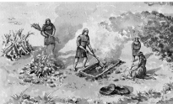
The Bronze Age began about 5000 years ago. Archaeologists use physics to help them understand the culture and technology of the Bronze Age.

Archaeologists often use radiocarbon dating to estimate the age of wooden objects. They do this by measuring the ratio of carbon–14 to carbon–12 in a sample and comparing it to this ratio for the carbon in a living tree.
- C–14 and C–12 are both isotopes of carbon. What are isotopes?
- The ratio of C–14 to C–12 in a sample from an archaeological artefact is found to be one quarter the ratio found in a living tree. Is the artefact from the Bronze Age?
- Justify your answer.

(for water at 4 °C, 1 litre = 1 kg; specific heat capacity of water = 4180 J kg^{–1} K^{–1}; half-life of carbon–14 = 5730 years)

2022 Deferred examination Question 14 (b)
- What is meant by nuclear fission?
- The equation below gives one of the many reactions in the fission of uranium–235.
${}_{92}^{235}{U+{}_{0}^{1}n}$ → ${}_{56}^{144}Z$ +${}_{X}^{89}Z+$ 3Y + Energy

- Is this a spontaneous nuclear reaction or an induced nuclear reaction?
- What numbers or symbols do X, Y and Z represent in the above equation?

The krypton–89 isotope decays by beta‐emission to rubidium.
The decay constant for the isotope is 3.67 × 10^{–3} s^{–1}.

- Calculate the number of atoms of krypton–89 in a sample of the isotope that emits 2.0 × 10⁵ beta particles per second.
- What is the half‐life of krypton–89?

Question 9 Higher Level 2023
Voyager I and Voyager II are spacecraft that were launched in 1977 to investigate the outer planets of our solar system.
The spacecraft are powered with radioisotope thermoelectric generators.
When the spacecraft were launched, each generator contained 4 kg of plutonium–238.
Each atom of plutonium–238 has a mass of 3.9529085 × 10^{–25} kg.

- Write a nuclear equation for the alpha decay of plutonium–238.
- Calculate the energy released during each decay of plutonium–238, in MeV.
- The energy released by the decay is converted into electrical energy in thermocouples.
State the thermometric property of a thermocouple.
- Draw a labelled diagram of the arrangement of a thermocouple.
- Plutonium–238 has a half‐life of 87.8 years.
Calculate the rate of decay of the plutonium in each generator in 1977.
- Calculate the year when only 1 kg of the plutonium will remain in each generator.
- The Voyager spacecraft are now beyond our solar system and they are maintaining constant velocities. Use one of Newton’s laws to explain why the spacecraft maintain constant velocities.

Fission and fusion Exam Questions 2002 – 2022

Nuclear fission: Ordinary level questions

2014 Question 10 [Ordinary Level]
- What is meant by radioactivity?
- In an experiment, the radiation from a radioactive source is passed through an electric field, as shown in the diagram.
What does this experiment indicate about radiation?
- Which type of radiation is unaffected by electric fields?
- Which type of radiation is positively charged?
- Which type of radiation is negatively charged?
- Give the name of radiation types 1, 2 and 3, in that order.
- Nuclear fission occurs in a nuclear power station.
Name a suitable fuel for nuclear fission.
- Explain the role of neutrons in nuclear fission.
- Explain how the control rods can control the rate of fission, or stop the reaction completely.
- Iodine–131 is a product of nuclear fission. The half-life of iodine–131 is 8 days.
What fraction of iodine–131 remains after 24 days?

2013 Question 12 (d) [Ordinary Level]
- Nuclear fission occurs in the reactor of a nuclear power station like the one shown in the photograph.
What is nuclear fission?
- Name a fuel used in a nuclear reactor.
- How can the reaction in a nuclear reactor be controlled?
- How is the energy produced in a reactor used to generate electricity?
- State a hazard of nuclear reactors.

2006 Question 9 [Ordinary Level]
The diagram shows a simple nuclear fission reactor.
Energy is released in a fission reactor when a chain reaction occurs in the fuel rods.
- What is meant by fission? Name a material in which fission occurs.
- Describe how a chain reaction occurs in the fuel rods.
- Explain how the chain reaction is controlled.
- What is the purpose of the shielding?
- Name a material that is used as shielding.
- Describe what happens to the coolant when the reactor is working.
- Give one effect of a nuclear fission reactor on the environment.
- Give one precaution that should be taken when storing radioactive materials.

2012 Question 11 [Ordinary Level]
Read this passage and answer the questions below.
The Fukushima nuclear disaster
In March 2011, following a powerful earthquake, the Fukushima nuclear reactor in Japan was shut down automatically.
A nuclear reactor generates heat by splitting atoms of uranium in a process known as nuclear fission.
The uranium is contained in the reactor’s fuel rods. A chain reaction is set up by the neutrons released during fission and these go on to split more atoms of uranium.
The power output of the reactor is adjusted by controlling the number of neutrons that are present. Control rods made of a neutron absorber capture neutrons.
Absorbing more neutrons in a control rod means that there are fewer neutrons available to cause fission. Therefore, pushing the control rods deeper into the reactor will reduce its power output, and extracting the control rods will increase it.

The Fukushima nuclear reactor continued to generate heat even after the chain reaction was stopped because of the radioactive decay of the isotopes created during nuclear fission. This decay cannot be stopped and the resulting heat must be removed by circulating cooling water through the reactor core.

When the reactor was shut down due to the earthquake, the pumps to keep the cooling water circulating should have been powered by electricity from the national grid or diesel generators. However, connections to the grid were damaged by the earthquake and the diesel generators were destroyed by the tsunami wave that followed the earthquake. As a result, no cooling was available for the reactor core and this resulted in the explosions and subsequent release of radiation, consisting of radioactive isotopes such as caesium and iodine, into the environment.
(Adapted from ‘Wikipedia', June 2011)
(a) What is meant by nuclear fission?
(b) What is radioactivity?
(c) What is a nuclear chain reaction?
(d) What is the function of the control rods?
(e) What type of material are control rods made of?
(f) Why did the reactor still generate heat even though the chain reaction had stopped?
(g) Why is it important to remove the heat generated?
(h) Give one advantage of nuclear energy.

2003 Question 10 [Ordinary Level]
- What is radioactivity?
- The diagram shows the basic structure of a nuclear reactor.
- A nuclear reactor contains (i) fuel rods, (ii) control rods, (iii) moderator, (iv) heat exchanger.
- Give the function of any two of these.
- In a nuclear reactor, energy is released by nuclear fission when a chain reaction occurs.
What is nuclear fission?
- What is a chain reaction?
- Thick shielding is placed around a nuclear reactor because of the penetrating power of the radiation emitted.
Name three types of radiation that are present in a nuclear reactor.
- Name an instrument used to detect radiation.
- Plutonium is produced in a nuclear reactor. It is a highly radioactive substance with a very long half-life. When the fuel in a nuclear reactor is used up, the fuel rods are reprocessed to remove the plutonium.
- Give two precautions that are taken when storing the plutonium.
2009 Question 10 [Ordinary Level]
Radioactive elements are unstable and decay with the release of radiation.
- How would you detect radiation?
- Name the three types of radiation.
- Which radiation is negatively charged?
- Which radiation has the shortest range?
- Which radiation is not affected by electric fields?
- Nuclear fission occurs in a nuclear reactor.
- What is nuclear fission?
- What is the role of neutrons in nuclear fission?
- Name a fuel used in a nuclear reactor.
- In a nuclear reactor, how can the fission be controlled or stopped?
- How is the energy produced in a nuclear reactor used to generate electricity?
- Give one advantage and one disadvantage of a nuclear reactor as a source of energy.

2017 Question 10 [Ordinary Level]
Radiation is released when radioactive elements decay.
- Name three types of radiation.
- Which type of radiation has no charge?
- Which type of radiation is the least penetrating?
- Which type of radiation is not deflected by magnetic fields?
- State one danger associated with nuclear radiation.
- State one precaution that should be taken when handling radioactive substances.

Radioactive fuels are used to generate power in a nuclear fission reactor like the one shown in the diagram.

- What is nuclear fission?
- Name a fuel used in nuclear reactors.
- State the function of (a) the control rods and (b) the shielding in a reactor.
- What is the purpose of the heat exchanger?

2019 Question 12 (d) [Ordinary Level]
Both nuclear fission and nuclear fusion are processes by which the nuclei of atoms are altered to create energy.
- ${}_{92}^{238}U$is a uranium atom. How many protons are in this uranium atom?
- How many neutrons are in this uranium atom?
- ${}_{92}^{235}U$ is another isotope of uranium. What are isotopes?
- Distinguish between nuclear fission and nuclear fusion.
- State one advantage and one disadvantage of nuclear energy.

2016 Question 12 (d) [Ordinary Level]
- Nuclear fusion is the source of the Sun’s energy.
What is meant by nuclear fusion?
- Name the other type of nuclear reaction used in nuclear power stations.
- State one advantage and one disadvantage of each of these sources of nuclear energy.
- Name the scientist whose equation E = mc² explained why a large amount of energy is available from a small mass of fuel in nuclear reactions.


2021 Question 12 [Ordinary Level]
Lise Meitner was an Austrian physicist who was the first woman to become a full professor of physics in Germany. In 1938, together with chemist Otto Hahn, she discovered nuclear fission.
- What is nuclear fission?

Fission reactors are used to generate electricity.
- What is the function of the control rods in a fission reactor?
- A fission reactor is surrounded by shielding. What is the purpose of the shielding?
- What material is used as shielding?
- State one disadvantage of nuclear fission.
- Meitner never won a Nobel Prize for her discovery, although Hahn did. She was honoured after she died by having an element named after her. The element is called meitnerium, Mt.
How many electrons are in an atom of Mt? (Refer to page 79 of the Formulae and Tables booklet.)
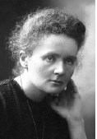
Marie Curie also has an element named after her, curium, Cm. Curie was the first woman to win a Nobel Prize, which was for her study into radioactivity.
- What is meant by radioactivity?
- There are three types of nuclear radiation: alpha, beta and gamma.
Which type of nuclear radiation is the most penetrating?
- Describe an experiment to compare the penetrating power of the three types of nuclear radiation.
- Curie also developed techniques for isolating radioactive isotopes.
What are isotopes?
- One isotope of curium is ${Cm}_{96}^{247}$
How many neutrons are in this isotope?

Nuclear fission: Higher level questions

2014 Question 8 [Higher Level]
A nuclear reactor is a device in which a sustained chain reaction takes place.
From each nuclear fission, only one (on average) of the emitted neutrons hits another nucleus to cause another fission. The power output from a sustained nuclear reaction doesn’t grow, but is constant.
- Explain the underlined terms.
- A substance called a moderator is mixed with the fuel in a nuclear reactor.
Control rods are used to control the rate of the reaction.
Give an example of a moderator.
- Explain why a moderator is needed in a nuclear reactor
- Explain how the control rods affect the rate of the reaction.
- A heat exchanger is used in a nuclear reactor.
Explain how the heat exchanger operates.
- Why is it necessary to use a heat exchanger?
- Plutonium is produced in a fission reactor when one of the neutrons released in the fission reaction converts uranium–238 into plutonium–239 with the emission of two beta-particles.
Write an equation for this nuclear reaction.
- Each fission of a uranium–235 nucleus produces 202 MeV of energy.
Only 35% of this energy is used to generate electricity.
How many uranium–235 nuclei are required to undergo fission to generate a constant electric power of 1 GW for a day?

2016 Question 9 [Higher Level]
- Lise Meitner and Marie Curie are the only women scientists to have elements named after them.
In the case of Meitner this was for her work on fission and in the case of Curie it was for her discovery of radium and her work on radioactivity.
Explain the underlined terms.

- The following is the nuclear equation of a fission reaction explained by Meitner.

$${}_{92}^{238}{U+ }{}_{0}^{1}{n → {}_{56}^{139}{Ba}}+ {}_{36}^{97}{Kr}+3{}_{0}^{1}n$$

Calculate the energy released during this reaction.
- How many of the neutrons emitted in a fission reaction must, on average, cause a further fission so that the reaction is self-sustaining and safe?
Explain your answer.
- The neutrons emitted are sometimes passed through a moderator.
Explain the function of the moderator.
- Radium–225 is a radioactive isotope that decays into an isotope of actinium.
Write a nuclear equation for the decay of radium–225.
- Radium–225 has a half-life of 14.9 days.
Calculate the number of radium–225 nuclei in a sample that has an activity of 5600 Bq.

(Nuclear masses: U–238 = 3.9529 ×10^{–25} kg; Ba–139 = 2.3066 ×10^{–25} kg;
Kr–97 = 1.6099 ×10^{–25} kg)

2008 Question 12 (c) [Higher Level]
- In 1939 Lise Meitner discovered that the uranium isotope U–238 undergoes fission when struck by a slow neutron. Barium–139 and krypton–97 nuclei are emitted along with three neutrons.
Write a nuclear reaction to represent the reaction.
- In a nuclear fission reactor, neutrons are slowed down after being emitted.
Why are the neutrons slowed down?
- How are they slowed down?
- Fission reactors are being suggested as a partial solution to Ireland’s energy needs.
Give one positive and one negative environmental impact of fission reactors.

2010 Question 12 (b) [Higher Level]
The following reaction occurs in a nuclear reactor:
$${}_{}^{235}{U+ }{}_{0}^{1}{n → {}_{}^{141}{Ba}}+ X+3{}_{0}^{1}{n+202.5 MeV}$$
- Identify the element X.
- Calculate the mass difference between the reactants and the products in the reaction
- What is a chain reaction?
- Give one condition necessary for a chain reaction to occur.
- Give one environmental impact associated with a nuclear reactor.

2018 Question 8 [Higher Level]
- Explain the terms nuclear fission and specific heat capacity.
- Water can act as both a moderator and a coolant in a nuclear fission reactor.
What effect does a moderator have on the rate of fission?
- How does a moderator have this effect?
- In a nuclear reactor core, 5000 kg of water is heated so that its temperature increases by 70 K and it is converted into steam.
Calculate the energy absorbed by the water.
- In a fission reaction a neutron is absorbed by a uranium–235 nucleus. Barium–139 and krypton–94 nuclei are released as well as some neutrons.
Write a nuclear equation for this reaction.
- Calculate the energy released, in MeV, in this reaction.

Nuclear fusion reactors could supply more energy than fission reactors.
- Explain why fusion reactors are not yet a practical source of energy on Earth.
- Give one other advantage that a fusion reactor would have over a fission reactor.

(specific heat capacity of water = 4180 J kg^{–1} K^{–1})
(specific latent heat of vaporisation of water = 2.23 × 106 J kg^{–1})
(mass of barium–139 nucleus = 138.90884 u,
mass of krypton–94 nucleus = 93.93436 u,
mass of uranium–235 nucleus = 235.04393 u)

2020 question 10 [Higher level]
- Why was Fermi’s nuclear reactor self‐sustaining?
- Graphite was used in his nuclear reactor. What was the purpose of the graphite?
- Is nuclear fission a spontaneous or a non‐spontaneous process? Explain your answer.

2019 Question 11 [Higher level]
Read the following passage and answer the accompanying questions.

Physics Rivalries
We tend to think of scientists as toiling away in their laboratories, not looking to bother anyone, but that’s not always the case. Great minds often come with powerful personalities. The rivalry between Nikola Tesla and Thomas Edison is the most famous example, but it’s far from the only one. Edison’s greatest conflict with Tesla was called the current war. It centred around whether a.c. or d.c. should be used to transmit electricity. Edison insisted his d.c. system was superior because it maintained a lower voltage in transmission and was therefore safer. Tesla’s a.c. eventually won out but it is still converted to d.c. for use in the home.

In the seventeenth century Robert Hooke was known as Isaac Newton’s most enthusiastic antagonist, claiming that much of Newton’s work was built on his own. The biggest disagreement involved Newton’s law of gravitation. Hooke always maintained that Newton took the idea of an inverse law from him. Hooke also discovered the plant cell using an early microscope. In 1938 Lise Meitner, using the result of an experiment of Otto Hahn, explained how nuclear fission occurs. This discovery led to a great injustice in science. Hahn was awarded a Nobel Prize for the discovery of nuclear fission. Hahn never fully acknowledged the contribution of Meitner to the understanding of fission. This deeply hurt Meitner, as did the fact that she was not given a share of the Nobel Prize.
Adapted from Rivals: Conflict as the Fuel of Science (Michael White); Plutonium, A History of the World’s most Dangerous Element (Jeremy Bernstein)

- Explain why the transmission of electricity using low voltage is not economical.
- Name the device used to (i) reduce a.c. voltage, (ii) convert current from a.c. to d.c.
- State Hooke’s law.
- A ball of mass 110 g is travelling at a speed of 4 m s^{–1}. It rebounds from a wall and travels in the opposite direction at the same speed. The ball was in contact with the wall for 0.2 seconds. Use Newton’s laws of motion to calculate the force exerted by the wall on the ball.
- A magnifying glass is a basic microscope.
Draw a ray diagram to show the formation of an upright image in a magnifying glass.
- A plutonium–239 nucleus undergoes fission when a neutron collides with it.
Xenon–134 and zirconium–103 are produced together with some neutrons.
Write a nuclear equation for this fission reaction.
- Calculate the energy released in this reaction.
- In what form is this energy released?

(masses of: Pu–239 = 239.052163 u, Xe–134 = 133.905395 u, Zr–103 = 102.926599 u)

Nuclear fusion: Ordinary level

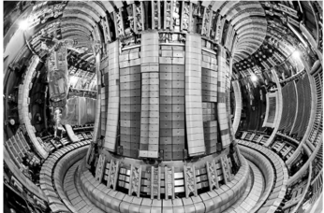
2023 Question 13
Read the following passage and answer the questions below.
It was recently announced that a team of researchers at the Joint European Torus tokamak reactor near Oxford generated the highest sustained energy pulse ever created using nuclear fusion, the joining of two atomic nuclei with the release of energy.
If researchers can harness nuclear fusion, the process that powers the Sun, it promises to provide a near-limitless source of clean energy. But so far no experiment has generated more energy than has been put in, due to the huge force of electrostatic repulsion between nuclei. These results do not change that, but they suggest that scientists should eventually be able to reach this goal.
To break the energy record, the scientists used a fuel made of equal parts tritium and deuterium.
Tritium is a rare and radioactive isotope of hydrogen, meaning it has the same atomic number as normal hydrogen but a different mass number. When tritium undergoes nuclear fusion with the isotope deuterium, the reaction produces more energy than a reaction involving deuterium only.
In this experiment, 59 MJ of energy was produced during a fusion pulse that lasted 5 s. This pulse generated more than twice the power of the previous record for nuclear fusion.
Adapted from: www.nature.com
- What is meant by nuclear fusion?
- Why is there a huge force of electrostatic repulsion between two nuclei that are brought close to each other?
- The scientists used isotopes of hydrogen in this experiment. What are isotopes?
- The symbol for tritium is $H_{1}^{3}$.
  - How many protons are in an atom of tritium
  - How many neutrons are in an atom of tritium?
- Tritium decays by beta emission. What is the daughter nucleus when an atom of $H_{1}^{3}$emits a beta particle?

- In this experiment, 59 MJ of energy was produced during 5 s.
Calculate the power generated.

- Nuclear power plants currently use nuclear fission, not nuclear fusion.
What is meant by nuclear fission?
- Large amounts of money are being invested into nuclear fusion research.
Why is there such interest in replacing nuclear fission with nuclear fusion?

Nuclear fusion: Higher level

2012 Question 8 [Higher Level]
Energy can be produced in a fusion reaction by combining a deuterium and a tritium nucleus as follows:
$${}_{1}^{2}{H+ {}_{1}^{3}H}→ {}_{2}^{4}{He+n+energy}$$
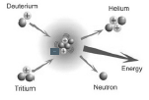
- Distinguish between nuclear fission and nuclear fusion.
- What are the advantages of fusion over fission in terms of fuel sources and reaction products?
- How much energy is produced when a deuterium nucleus combines with a tritium nucleus?
- Calculate the force of repulsion between a deuterium and a tritium nucleus when they are 2 nm apart in free space.
- Fusion can only take place at very high temperatures. Explain why.

2006 Question 8 [Higher Level]
- Distinguish between fission and fusion.
- The core of our sun is extremely hot and acts as a fusion reactor.
Why are large temperatures required for fusion to occur?
- In the sun a series of different fusion reactions take place. In one of the reactions, 2 isotopes of helium, each with a mass number of 3, combine to form another isotope of helium with the release of 2 protons.
Write an equation for this nuclear reaction.
- Controlled nuclear fusion has been achieved on earth using the following reaction:
$${}_{1}^{2}{H+ {}_{1}^{3}H}→ {}_{2}^{4}{He+{}_{0}^{1}n}$$
What condition is necessary for this reaction to take place on earth?

- Calculate the energy released during this reaction.
- Give one benefit of a terrestrial fusion reactor under each of the following headings:
  - fuel; (b) energy; (c) pollution.

speed of light = 2.998 × 10^{–8} m s^{–1}; mass of hydrogen-2 nucleus = 3.342 × 10^{–27} kg ;
mass of hydrogen-3 nucleus = 5.004 × 10^{–27} kg; mass of helium nucleus = 6.644 × 10^{–27} kg;
mass of neutron = 1.674 × 10^{–27} kg

SOLUTIONS TO ORD. LEVEL EXAM QUESTIONS (MATHS PARTS ONLY) 2002 – 2022

2005 Question 12 (d)
What fraction of a sample of Na−25 remains after 3 minutes?
After one minute half has decayed and half remains
After 2 minutes (2 half-lives) ¾ has decayed and ¼ remains
After 3 minutes 7/8^{ths} has decayed and 1/8th remains.

2011 Question 10
How long would it be until one eight of the radon gas was left?
The half-life is 4 days, so after 4 days ½ would remain,
after 2 half-lives (8 days) ¼ would remain,
after 3 half-lives (12 days) 1/8 would remain

2014 Question 10
What fraction of iodine–131 remains after 24 days?
The half-life is 8 days, so after 8 days ½ would remain,
after 2 half-lives (16 days) ¼ would remain,
after 3 half-lives (24 days) 1/8 would remain

2020 Question 12 (d)
Calculate the atomic number, A, of the unknown element X.
86 – 2 = 84
Calculate the mass number, Z.
220 – 4 = 216
Name element X.
From 79 of the Formulae and Tables booklet: element with atomic number 84 = Polonium (Po)
2021 Question 12
How many electrons are in an atom of Mt?
${Mt}_{109}^{268}$ There are the same number of electrons as protons (109) so 109 electrons.
How many neutrons are in this isotope?
247 – 96 = 151 neutrons
2021 Question 13
A drop has a volume of 2.03 × 10⁻¹⁷ m³ and a density of 886 kg m⁻³. Calculate the mass of the drop.
$Density (ρ)=\frac{mass}{volume}$ Mass = ρV Mass = (886)(2.03 × 10⁻¹⁷) = 1.8 × 10⁻¹⁴ kg

2022 Question 12
Calculate the wavelength of light of this frequency.
c = f λ λ = (3 × 10⁸) ÷ (6.5 × 10¹⁴) = 4.6 × 10^{–7} m

Calculate the energy of a photon of this frequency.
E = hf E = (6.6 × 10^{–34}) × (6.5 × 10¹⁴) = 4.3 × 10^{–19} J

2022 Question 14 (d)
- How many neutrons are there in an atom of ${(Ra}_{88}^{226})$?
226 – 88 = 138
- What is the daughter nucleus when an atom of ${(Ra}_{88}^{226})$ emits two alpha particles?
If it emits two alpha particles then the atomic number reduces by 4. 88 – 4 = 84.
From 79 of the Formulae and Tables booklet: element with atomic number 84 = Polonium (Po)

Michelson is famous for establishing the speed of light. He was stating a commonly held belief that scientists knew pretty much everything there was to know about physics. Around the same time as Michelson was making these remarks several remarkable and highly-important discoveries were crowded into the short space of ten years: X-rays in 1895, radioactivity in 1896, the electron in 1897, quantum theory in 1900, and special relativity in 1905. Individually, each had enormous significance and collectively they heralded what is now known as ‘modern physics’.
Scientists were aware of the approximate size of the atom by this stage. To give you some sense of how small the atoms are, note that one teaspoon of water contains more atoms than the Atlantic ocean contains teaspoons of water.
At the time nobody knew what alpha particles actually were – hence the name. Now we know that they have the same structure as helium nuclei.
We now know that the radius of a nucleus is about 10⁻¹⁵ m, while the radius of an atom is about 10⁻¹⁰ m.
The most famous analogy for the distribution of mass in an atom is to compare the atom to a fly in a cathedral, where the electrons are out where the walls of the cathedral would be and all the mass of the cathedral is located within the fly hovering around the middle of the cathedral. A nice classroom model is a hula-hoop with a ping-pong ball or golf ball hanging in the middle representing the nucleus. The full stop at the end of this sentence would be closer to scale but possibly a little harder to see. Now get a fistful of other golf balls, stand well back and fire them one at a time through the hula-hoop. Where does this analogy break down? We now know that the positive nucleus consists of positively-charged protons and neutrons which have no charge (neutral). So what does this mean? Each atom is 99.999999999 % empty space. Now all matter, including you, me and whatever you happen to be sitting on, is made up of atoms. Which means that you are almost completely empty space too! In fact if we could somehow remove all this empty space in your body and just keep the solid bit, it would be about the size of a grain of sand. As one scientist famously declared; “the world is not only queerer than we suppose, it is queerer than we can suppose”. So here are the real questions: - Why do objects look solid? - Why do objects feel solid? - Why do objects sound solid?
- They spin. Very clucking fast. They are like the ice skater who spins faster and faster as she brings in her arms (these are both wonderful examples of something called conservation of angular momentum). One particular neutron star (known as PSR J1748-2446ad), rotates at a rate of 716 times a second!! - As they spin some emit pulses of electromagnetic radiation. These were first detected by an Northern Irish astro-physicist called Jocelyn Bell Burnell who was working on her thesis at the time. Because these pulses were so regular (and she had no idea where they were coming from) she thought it would be funny to call the source LGM (for Little Green Men). This lady is one of the most wonderful scientists I have ever had the pleasure of meeting. Her thesis supervisor was awarded a Nobel Prize, partly for his part in this discovery. Jocelyn was not included. Boo! Hiss! In 2018, she was awarded the Special Breakthrough Prize in Fundamental Physics which came with $3 million in prize money. She chose to donate all of this money to establish a fund to help female, minority and refugee students to become research physicists. - If neutron stars become sufficiently dense they collapse to form a black hole. - On Dec. 27, 2004, for a tenth of second, a blast of energy knocked satellites offline, disrupted submarine and radio transmissions, and shifted the magnetic field of the Earth. The cause was an ‘earthquake' on a neutron star 50,000 light years away. https://scienceline.org/2016/01/starquake/
Because the activity of an atom is determined by the number and arrangement of electrons, it is sometimes said that “protons give the atom its identity; electrons give it its personality”. Nice.
It turns out that the ratio of the mass of the neutron to that of the proton is approximately 1.001. It is exactly the ‘right’ ratio to allow for nuclear fusion in stars. If it were any different we would not be here. Spooky.
Marie Curie Polish-born French physicist famous for her work on radioactivity. She is the only person who has ever won Nobel Prizes in both physics and chemistry. Her notebooks are actually classed as 'intermediate nuclear waste' and kept in a lead box in Paris Marie discovered a new element while working on radioactivity. At the time (circa 1900) her country was in danger of being annexed by Germany. Fearing nobody would ever remember that her country had even existed, she called the new element Polonium so we would never forget.
*Radioactivity is the disintegration of unstable nuclei with the emission of one or more types of radiation. I think that the greater the discrepancy between the number of protons and the number of neutrons, the more radioactive an element is, and it is this discrepancy that causes the nucleus to become unstable in the first place (but that’s as much as I know about it). Also, the higher up the periodic table you go, the greater will be the discrepancy between number or protons and number of neutrons and therefore there is a greater likelihood that these elements will be radioactive. So to recap; the nuclei of some atoms are unstable and as a result break up to form more stable nuclei. These new nuclei may in turn break up further. If we know what type of atom it is, we will be able to predict the changes which will take place within the nucleus (or at least know what the limited options are). But here’s the kick: There is absolutely no way of knowing when an individual atom will decay (decay is a strange word to describe this process, but then it’s a strange process) AND there is absolutely no way of affecting the process or put it more scientifically, the decay process is unaffected by physical or chemical factors. So you can hit the atom with a kango hammer, dip it in a bath of sulphuric acid, heat it with a blow-torch or caress it softly while whispering sweet nothings in its ear – it won’t make any difference. It will decay when and only when it’s good and ready. It is a truly random or spontaneous event (as opposed to tossing a coin for instance). For what it’s worth, this has serious philosophical implications as it sets a limit to how much science can ever know. When radioactivity occurs naturally it is completely random, but it can also be induced artificially. In case you missed the significance of this statement, it is big, big news. It means that you can never predict when a particular atomic nucleus will disintegrate. Even Einstein could never accept this. Einstein was wrong. More on this later.
Etymology of the word radiation The term radiation comes from a Latin root and literally means to spread out from a common centre. Three motorways radiate out from Dublin. Jane radiates beauty.
Helium is the only element on the periodic table which is non-renewable; almost all it only exists as a result of alpha decay which took place deep underground through the natural radioactive decay of elements. We are now in danger of using it all up because of our obsession with birthday helium balloons. This is why we cannot have nice things.
Some books put the bigger number on the bottom and the smaller number on top, just remember that the mass number will always be the larger number. The nuclei on the right are referred to as ‘daughter products’.
*In this case a neutron decays into a proton and an electron I have to admit that I always grimace when I read this in text-books. It’s as if this is the most natural thing in the world, like Kerry winning the All-Ireland. The phrase represents all that is wrong with physics textbooks – no wonder people think physics is boring. Let’s take a look at this again. “A neutron splits up into a proton and an electron”. Electrons do not, as a rule, live inside neutrons. In fact they have nothing at all to do with the nucleus of an atom, they orbit the damn thing. AND an electron is charged, a neutron is not. AND a neutron only has quarks in it, and quarks and electrons are completely different (we cover this in the Particle Physics chapter at the end). So how/why can a neutron spit out an electron? Well here’s the thing; once the process doesn’t break any of the laws of physics (e.g. conservation of energy, charge, momentum etc) then it’s allowed, and this process just doesn’t break any of those laws. By the way, don’t make the mistake of assuming that the neutron is actually a proton and an electron bound together, which come apart. That idea was rejected in the 1930s. (and a neutrino) Beta decay also includes the emission of another particle called the neutrino, which wasn’t discovered until decades later, so for some reason we ignore it in this chapter but include it when studying the Particle Physics chapter.
The –1 below the electron symbol obviously doesn’t represent an atomic number; it is merely a little accounting trick which allows us to equate numbers on the left and right hand sides of the equation.
Neither the term ‘decay’ nor ‘disintegration’ seem to adequately describe the process whereby an atom of one element changes into an atom of a different element but the long and short of it is that we just don’t have the requisite imagination to do any better. “We must be wary of using this word ‘transmutation’ – lest people believe us to be alchemists.” Rutherford. Alchemists used all sorts of potions to try to turn lead into gold. They were also interested in creating something called the elixir of life – supposed to be responsible for eternal youth. They tended to use urine as a raw material rather a lot. All in all rather a strange bunch – a bit like the modern-day chemistry teacher. Something most textbooks are uncomfortable with is the fact that the great Isaac Newton spent over 90% of his time as an alchemist. One noted historian claimed that Newton was not the first great scientist; he was the last of the great mystics. “I have observed many transformations in my work on radioactivity, but none so rapid as my own transformation from a physicist to a chemist” Rutherford again, this time on receiving the Nobel Prize for chemistry (hate da’).
The term $\frac{dN}{dt}$ is used in the Formula & Tables book but I prefer not to use it as it’s not as obvious to students as the term ‘Activity’.
Einstein could never accept the probabilistic nature of radioactive decay: “Quantum Mechanics is very worthy of regard. But an inner voice tells me that this is not yet the right track. The theory yields much, but it hardly brings us closer to [God’s] secrets. I, in any case, am convinced that He does not play dice.”
Half-life I’m not convinced that this second version of half-life is valid because if the daughter nuclei are themselves radioactive then the time taken for number of parent nuclei to halve (proper definition) is not the same as the time for the activity to halve. One of many analogies for half-life is the gold leaf electroscope. They are very easily broken. In fact, after every 40-minute class using them, approximately half of them need to be repaired. It is (almost) impossible to predict in advance which electroscopes will break (although one could take a look at the students involved and make an educated guess from there). Assuming that the broken ones do not get repaired, the half which are still in working order get handed out in the next class. After 40 minutes, half of these come back broken. You could say that the half-life of gold leaf electroscopes is 40 minutes. We can say the same about the decay of a large number of radioactive atoms (of the same element). If the element is radon, then after a specific amount of time approximately half of the atoms will have decayed. This time will be the same no matter how many atoms or radon are present. It’s like if I toss a coin a large number of times we can be confident that it will come up heads approximately half of the time. Except that tossing a coin isn’t really random. Theoretically if we knew the momentum imparted to the coin as it was fired upward together with knowing where exactly on the coin the force was applied plus air resistance and a bunch of other variables, we could (with a suitably powerful computer) be able to predict whether the coin will land heads or tails. It would be very complex – but here’s the key point – it wouldn’t be random. Not so with radioactive decay. The time it takes half of the radon atoms to decay is unique to radon and is called the half-like of radon. Each element has its own unique half-life. Protactinium-234, for instance, has a half-life of 1.2 minutes while uranium-238 has a half-life of 4.5 billion years. The record for the element with the longest half-life belongs to Xenon-124. It has a half-life of 18 sextillion years (18 × 10²¹ years)– over 1,000,000,000,000 times the current age of the universe. See the decay-chain image for more examples. Did you know that the term ‘half-life’ also applies to drugs in the body? The elimination half-life of a drug is defined as the time it takes for the concentration of the drug in the body to be reduced by 50%. In other words, after one half-life, the concentration of the drug in the body will be half of the starting dose. In general, the effect of the drug is considered to have a negligible therapeutic effect after 4 half-lives, that is, when only 6.25% of the original dose remains in the body. https://www.news-medical.net/health/What-is-the-Half-Life-of-a-Drug.aspx
Google ‘derivation of radioactive decay formula’ to see where the formula for half-life comes from. It’s nice and short.
Did you know? Each cubic metre of garden top soil contains typically 0.5 grams of uranium and the members of its decay chain and 1.5 grams of thorium and the members of its decay chain. Brazil nuts contain small amounts of radium. Although most of it is not retained by the body it is still 1,000 times higher than in other foods. A 70 kg human has about 9 kBq of natural radioactivity; mostly K-40 and C-14.
This is the principle behind the original atomic bomb. So where did the energy come from? From the fact that the total mass of all the particles after the explosion was less than the total mass before, and the missing mass (or ‘mass defect’) manifested itself as kinetic energy of the particles produced. The atomic bomb dropped in Hiroshima in August 6th, 1945, killing over 140,000 people (called Little Boy) contained 64 kg of uranium, of which 0.7 kg underwent nuclear fission, and of this mass only 0.6 g was transformed into energy (i.e. disappeared), but as a result the other particles produced flew off at enormous speeds, enabling them to produce maximum destruction, misery and carnage. Isn’t science wonderful? However as a result of the damage caused by these atomic bombs, scientists began to question the morality of their work like never before. ‘Pugwash’ (www.pugwash.org) is an organisation set up by scientists to promote peace, and many top scientists are members.
E=mc² “A few years ago I was reading an interview with the actress Cameron Diaz in a movie magazine. At the end the interviewer asked her if there was anything she wanted to know, and she said she’d like to know what E=mc² really means. They both laughed, then Diaz mumbled that she’d meant it, and then the interview ended. ‘You think she did mean it?’ one of my friends asked, after I read it aloud. I shrugged, but everyone else in the room – architects, two programmers, and even one historian (my wife!) – was adamant. They knew exactly what she intended: They wouldn’t mind understanding what the famous equation meant, too. It got me thinking. Everyone knows that E=mc² is really important, but they usually don’t know what it means. That’s frustrating, because the equation is so short that you’d think it would be understandable.” From E=mc²: A Biography of the World’s Most Famous Equation http://www.davidbodanis.com/books/emc2/#more
Do not worry about your difficulties in mathematics; I can assure you that mine are still greater. Albert Einstein to a junior high school student Barbara Wilson, January 7, 1943. The mathematical education of the young physicist [Albert Einstein] was not very solid, which I am in a good position to evaluate since he obtained it from me in Zurich some time ago. Hermann Minkowski. Burn.
Better phrasing for this question: “In the Sun, 4 × 10⁹ kg of mass energy is converted into electromagnetic radiation energy every second. Calculate the energy involved in this conversion each second.” In fact the sun generates more energy in a second than has been used across the whole of human history. This means that the mass of the sun is decreasing every day. But don’t worry - it’s not likely to run out any time soon. The good news is that Global Warming will get you long before then.
Just to give an indication of how much energy this is, compare 4 × 10⁹ kg (4000000000 kg) to the mass of uranium that was ‘released’ and destroyed the city of Hiroshima in 1945: 0.7 grams.
If you have two pieces of lego and join them together it stands to reason that the total mass at the end is equal to the sum of the masses of the individual pieces. One would assume that the same would apply when adding protons together in a nucleus. Not so. In fact if you combine two neutrons and two protons together to make a helium nucleus the combined mass of the individual particles beforehand will in fact be greater than the mass of the helium nucleus. Consider it from the perspective of breaking apart a helium nucleus; the nucleons are stuck together so you need to do work to pull them apart, much like doing work to pull apart two magnets. This work is done ‘on’ the nucleons and the mass associated with this energy is added to the mass of the neutrons once separated. Hopefully you can now see why the reverse would happen if you combined the nucleons. The energy is referred to as nuclear binding energy (poorly named, in my opinion at it is the energy needed to separate nucleons. Excellent explanation here: link
The atomic mass unit is defined as being equivalent to one 12th the mass of a carbon-12 nucleus.
Living with Albert Einstein married Mileva Marić in 1903, but by 1914, things had soured (he was actually having an affair with one of his cousins at the time of writing this) and the scientist wrote his wife this letter of rules she had to obey if she wanted to stay married: You make sure: - You make sure that my clothes and laundry are kept in good order and repair.That I receive my three meals regularly in my room. - You make sure that my bedroom and my office are always kept neat, in particular, that the desk is available to me alone. - You are to renounce all personal relations and refrain from criticising me either in word or deed in front of my children. - You are neither to expect intimacy from me nor reproach me in any way. - You must desist immediately from addressing me if I request it. - You must leave my bedroom or office immediately without protest if I so request. They divorced shortly after.
In the original atomic bombs, two pieces of fissile material of sub-critical mass are suddenly brought together using conventional explosives, creating a critical mass and the condition necessary for an uncontrollable chain reaction. There is a spot in Africa (Gabon I think) where tens of millions of years ago a chain reaction occurred naturally, resulting in what was possibly the world’s first nuclear explosion! Nuclear fission and atomic bombs The guy in charge of the Atomic Bomb research project in Los Alamos, New Mexico during WWII was called Robert Oppenheimer. When he saw the mushroom cloud from the very first atomic bomb which was set off as a trial, he uttered the words ‘I have become death – the destroyer of worlds’. Oppenheimer himself was later considered a ‘security risk’ by the United States government in spite of there being little if any evidence against him. It may have been because he wanted to scale down investment in nuclear weapons, while another scientist – Edward Teller – wanted the opposite. Teller was a shrewd operator and got his way and is now known as the father of the Hydrogen bomb, which we’ll come back to when we get to nuclear fusion. Heisenberg and the atomic bomb In WWII while the Allies were working on the Atomic bomb, the Germans were working on their own version. The head of the German project was Werner Heisenberg – famous for ‘Heisenberg’s Uncertainty Principle’ (or as the name of Walter White’s alter ego in Breaking Bad). Heisenberg is also famous for being one of the founders of Quantum Theory. But Heisenberg miscalculated what the critical mass would be and as a result the Germans never did produce an atomic bomb. A question historians wonder about is whether or not Heisenberg did this deliberately in an attempt to sabotage the project for ethical reasons, or was it merely a blunder?
The accident in Chernobyl occurred because while the reactor was overheating and the control rods didn’t function properly. There is still debate as to whether this was due to a faulty design or to human error.
The energy produced by an atom is a very poor kind of thing. Anyone who expects a source of power from the transformation of these atoms is talking moonshine. Rutherford. Oopsies. These transformations of the atom are of extraordinary interest to scientists but we cannot control atomic energy to an extent which would be of any value commercially, and I believe we are not likely ever to be able to do so. Rutherford in a letter to Nature, 1933. Oopsies again . . .
Sellafield reprocessing plant: Sellafield is not an electrical energy generating station. It takes in uranium which has already been used as fuel which means that the concentration of uranium 235 is to low for further fission. The fuel rods need to be ‘enriched before they can be re-used.
Note that both nuclei beforehand are isotopes of hydrogen (same atomic number).
Nuclear fusion and atomic bombs While scientists may not be able to control nuclear fusion in nuclear plants, it doesn’t mean that it doesn’t happen. No Sir. All modern atomic bombs work on the principle of nuclear fusion. So how do they get the energy necessary to cause two deuterium nuclei to collide? Easy – they use a traditional nuclear fission atomic bomb. Ingenious – no? The advantage of the hydrogen (fusion) bomb over the older atomic (fission) bomb is that the new version releases much more energy. Which is a nice way of saying that it can kill more people. A lot more people. Apparently this is a good thing. You may also have noticed that some of the terms are confusing. After all, both types of bomb (fission and fusion) are ‘atomic’ and both are ‘nuclear’. I guess the way scientists distinguish one from the other is that a fusion bomb involves hydrogen, and so is called a ‘Hydrogen bomb’.
There are a couple of prototypes, e.g. ITER in France (which contains an electromagnet strong enough to lift an aircraft carrier) but all are about 30 years from becoming commercial. Mind you they have been saying this for over 50 years; the in-house joke is that fusion reactors are just 30 years away - and always will be.
I have no idea why.

